

Bank of England

Inflation Report

August 1993

Inflation Report

August 1993

Recent price developments

###### .1 Retail prices

1.2 Manufacturing prices Domestic deflators ‘Core’ inflation

Other measures of inflation

###### 1.6 Summary 10

*’Core inflation revisited:1*

2 Monetary and fiscal policy

Monetary aggregates Interest rates

The exchange rate 16

2.2 Fiscal policy

*The velocity of c’irculation of nioiie j’*

###### Demand and output 19

Demand 19

Personal spending 19

Investment and stockbuilding 21

Overseas trade 22

Output and the output gap 23

The labour market 25

Earnings and settlements 25

4.2 Labour productivity and unit

29

*The link between wage settlements and earnings inflation*

5 Price **dynamics** 30

**External influences on inflation** 30

###### Commodity prices 30

###### Overseas inflation

###### Recent developments in import prices

5.2 Input prices 32

.3 Business profitability

* 1. Evidence from financial markets
  2. Outside forecasts
  3. Surveys of inflation expectations
  4. Bank projections 3g The short-run outlook 38

Longer-term projections 38

Uncertainties 40

*Implied forward interest rates and*

*future inflation rates* 36

###### Conclusions 42

Reprinted from the August f993

Bank of England g«ar/er/y 6«//a//n

Printed 6y Bumips Lid, 8t Ives plc Bank of England 1993

ISBN 1 85730 012 2

Summary

The *Inflation Report* reviews recent developments in inflation and presents the Bank of England’s analysis of tuture prospects. It contai.ns seven sections covering:

1. recent price developments:
2. monetary and fiscal policy; demand and output;

the labour market; price dynamics;

the prospects for inflation; and conclusions.

Inflation has continued to fall throughout the period since the May *Report.* The headline inflation rate has fallen to 1.2% a year, the lowest for nearly thirty years. Underlying inflation, defined in terms of **RPIX,** has fallen from a rate of 3.Sta in March to 2.89• in June, the .Iowest figure since the index first became available.

The inflation outtum has been lower than projected at the time of the last *Report.* This is partly because food, alcohol and tobacco did not increase in price as rapiclly as expected, taking into account the usual seasonal panern, and partly because price increases

across the range were lower than implied by their recent behaviour. Inflationary pressures have continued to weaken. Such large divergences between the outtum and the previous projection constitute news about underlying inflation. The ratio of retail to wholesale prices fell .more than expected. The impact of sterling depreciation .on import prices has been offset by a reduction in unit labour costs, leaving total costs .broadly unchanged.

Monetary policy is.based on an assessment of the direction in which inflation is moving one to two years ahead. and not or the backward-looking measure.of the increase in prices over the past twelvg rnonilis: The Barik’s central projection is that inflation will remain withifi ti e target.!rangñ over tfie next tWo years. It is iihportant:to distinguish between RPIX inflation, used in the definition of tie.target ran!ge; and a measure of underlying



inflation which excludes changes in both indirect and local authoFlty taKes. Excluding the effects of taxes, the underlying rate of inflation is expected to decline further over the next year and then to remain broadly .constant into 1995. In contrast, RPIX inflation will increase in the first half of 1994 as a result of the extension of VAT to domestic fuel and power (and any indexation of excise duties to be announced in the November Budget) and the change from the Community Charge to the Council Tax dropping out of the twelve-month rate. The official measure of underlying inflation may, therefore, be close to the top of the target range in the first half of 1994.

The evidence on expects\tons of inflation suggests that it is expected to remain within the target range over the next two years or so. But market expectations derived from the yield curve do not yet appear to be consistent with the achievement of the inflation target over the neKt decade. Credibility of the target over this horizon matters because it affects the level of long-term interest rates. Such rates are also influenced hy the level of the budget deficit. The prospective rise in the ratio of government debt to **GDP** is of concern because it may lead to fears that the real burden of this debt will eventually be monetised.

The recent reductions in inflation improve the prospect that inflation will remain within the target range, which will enhance: the credibility of the target range itself. But it is important that adherence to the target range is not interpreted simply as holding inflation below 4% a year. Part of the original statement of the target was that inflation should be in the lower half of the range by the end of this Parliament. That outcome is within reach provided that monetary policy does not accommodate increases in nominal costs, and that fiscal policy does.not threaten the.inflation target in the longer run.,



## Chart 1.1 Infladon

ce i es

Underlying inflatio efined as the twelve-month

" change in the Retail Prices If1 de x e Xc1uding mortg ilge

„ interest payments (RPIX) has fallen since the last

*Inflation Report.* It was 3.5&r in March but fell *to*

, 2.9&• in April and 2.8% in May and June (see

Chart 1.1). The fall was matched by a decline in the

* ‘headline’ rate of infiation (which includes mortgage interest payments). It fell from 1.9% at the time of

the list Report to 1.3% in April and May and 1.2' o in

June.

- 2





Chart 1.2

**Underlying inflation**

- 4







**Coat¿ihutioas to under)ying•infIstiop,**

A fall in inflation was widely expected for April, because of the ending of the Community Charge. The new Council Tax payment is about 99r less for a representative household than was the Community Charge. The change *reduced* RPIX by an estimated 0.3& between March and April. The twelve-month change in the index fell even more because between 1991/92 and 1992/93 the Community Charge had *raised* the index by about 0.4 percentage points (see Table l.A). The full impact of the change is the sum of these contributions, which amounts to a reduction in the twelve-month change in RPIX of

0.7 percentage points. Excluding both this factor and also indirect taxes, inflation, at 3.2%, has fallen since April (Charts 1.2 and 1.3) after increasing earlier in the year. This increase reflected the rise in import prices following the depreciation of sterling between SeplembeT and February.

Table 1.A shows that goods are contributing a little

.more!to underlying inflation than at the time of the *last Sepori.* By contrast, services are contributing a little less. Although both changes are small, they reflect some further passing on of higher import prires after sterling’s depreciation last September. However, the contribution to the underlying inflation rate from clothing and footivear, and household and leisure goods, where imports account .for a rélatively high propoñion of sales, has fallen slightly since the lgst *Report.* Within services, the contribution (rom

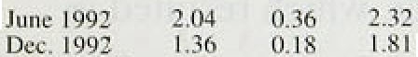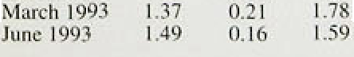

.O:OI -0.30’: 2’:8

ihñ::ewly privatised utilities and public co orations

. .. . , = . .

has The shows that

dimintshed.. table administered:

Inf\n\ion Re{t‹›n: Augutl WS

Chart 1.3

Price. changes

gible net .contributioii to.the

Coni’entional measures of inflation





tiiJc I ’tJ2 Dec. I qq 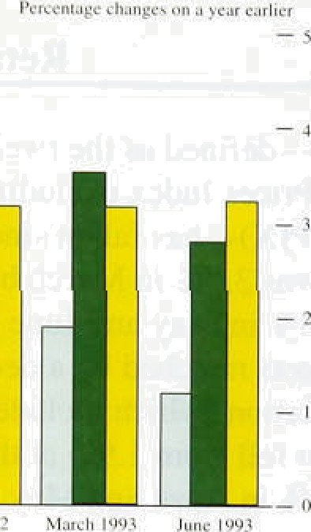

Table I.B

Shi›rt-run **measures uf inflati‹›n**



RPIX RPJX

|  |  |
| --- | --- |
| Goudv | Semices |
| 0.8 | 5.0 |
| 1.4 | 4:9 |
| 2:ti | â..0 |
| 3.7 | 6.2 |
| 2.0 | 2:5 |

<xc1uding



Juncl902 3.5 3.4 2.4

September 1992 2.4 2.II 2.4

Oecember 1992 0.3 ].8 3.7

March 1993 0.7 3b 4.0

June 1993 I .0 0.8 *.8

i•i o• c h*ngc in the liiiexi monili oii ihrec menthi earlier. see ‹›rolly aajustoa ma



**Chart 1.4**

###### Recent retail price developments



underlyingl inflation rate i'n Jufie, ,compared..w.ith:about 0.2.percentage,points,at the. time. of.the last *Répor.t, an*d

0.4 percentage points â ye’at a!go:

Inflationary developments take time to be reflected fully in conventional twelve-month inflation rates. Table! .l.B shows price changes, measured over three-month periods. The figures are se'asonally adjusted and annualized to allow comparison with standard measures, though the process of seasonal adjustment is not.straightforward and short-run measures are more volatile. Even so, the

three-month .rates do offer,a more up-to-date picture of inflation. The short-ran measure of underlying inflation has fallen sharply since the last.Report. As with the twelve-month measure, however, the fall is partly due to the switch from Community Charge to Council Tax.

When both local authoriJ and indirect taxes are excluded, the decline is smaller, although the rate is below the twelve-month figure. The prices of many items in the clothing and footwear,.household and leisure goods sectors are going up more slowly than three months ago; this is partly because of the early start to: the summer sales this year. And food prices havé.risen more slowly after increasing sharply between December and March (see Chart 1.4). Inflation in the service sector.has also fa:lien considerably



The chart shows that the gap between the rates of growth of goods and services prices has narrowed during the past year,as,the impact.of.last!autumn’s depreciation. has

:affecteld the. two sectors very di.fferently.

1 2 a t n e

In!the twelve months to June, manufacturers’ output prices increased by 4.0 .,.up from 3.8&o in April. Most of this change 1s attributable .to faster increases in prices of food, drink and tobacco. In the year to .June„pnces

.for these sectors increased by,6.3, i, up from 5.9&a.in Apri.1, and from. 4.89c in:the year to. June 1992. Part of



in passing through the.higher excise duties an.noiinced‘in the March B.udget. Tfir, greater part, though; especially continuing into June,:comcs fr‹im the .‘green **.pound!’** devaluations:at the turn of the year, which resiilted in

,sharp increases‘iii fnput cpsts.!.



’Exclufii!ng:.food; drink:and:to.baceo, manufactiiriog. ootput pricea rose’by 2.6.d in the year to June,



hsrt: t.5.

**Producer output price ini”Iation**

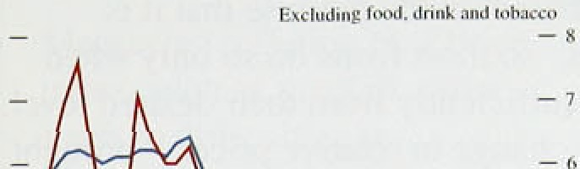



Chart 1.1). In the three months to June. producer prices (excluding food, drink and tobacco) rose at *on* annualised rate of 2.9% (see Chart 1.5). This is

0.3 percentage points below the April rate. Though more volatile than its corresponding twelve-month rate, this shorter-run measure suggest.s there is little upward pressure on factory gate inflation.

# Domestic dei’lators

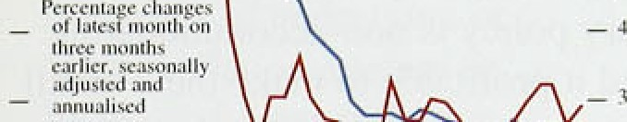— The GDP deflator is a measure of inflation for total output produced at hone. In the first quarter of 1993, the factor cost GDP deflator (which excludes indirect

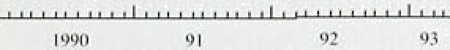 taxes and subsidies) rose by 0.79r. In the year to the

first quarter, the deflator rose by 2.One. its smallest increase since .1964. Table I.D shows the deflator for GDP and its components. The lai ge variations between

*•* • -* the different components partly reflect the consistently **D‹iniestir deHalor. xpendilur """*""""'"** lower rate of inflation for goods than for services. As a icnP o$‘ '“’ meni' E' " ^" result, components which contain a big share of

.Percenu#echangcs un.,...,., „ expenditure on services, such as government

1991 .Q2 6.6 .8 -• › • , , ., consumption. also tend to have high inflation rates. The



: Q4 4.9 6.0 -2.6. 6:6 -0.fi o.l

1992 'Ql: .4.9.. ,fi 1, -4.4 6.G. 1.6 0.4



rate of increase in the GDP deflator has fallen since 1990. when it reached 9.1%. As the GDP deflator measures domestic costs, any rise in import prices that

"’ ‘° ' ' " ' is not passed on (but is instead absorbed in margins) will

1 993 Q1. * 0 4.p .l 7 6.5 6 8 cause the GDP deflator to fall, as it did in the fourth

Percentage incre:ise,'on prc•vious quarter (seasonaily adjustedl: quarter of 1992.



### Core inflation



**Ctiart 1.6**

**Measures of ‘core’ inflation**





**’,RPk.c’:’**



Large changes in relative prices may lead to a sudden but temporary change in measured inflation: exaniple4 include the prices of seasonal foods and petrol. It is not easy to be sure whether a change in measured inflation is .temporary or is part of .a longer-term process of adjustment. For this reason it is useful to try to identify a 'core’ rate of.inflation.

Chañs 1.6 and 1.7 show measures of core inflation using two different approaches. In Chart 1.6. the ‘core’ is defifie‹i by .removing those prices which, either because they are volatile or because they are controlled by government, .are deemed unrepresentative of the p•eneral level of prices. The chart shows two such measures. togetlier with underlyirig. inflation (RPIX). The two iñove broadly tog•ether:. Chart 1:7 shows two further crime measures—a medixn inflation rate,. and.a weighted **averagé** of the central 70% of the distribution: of price changes (.ie the: average after.excluding'the lar est 159





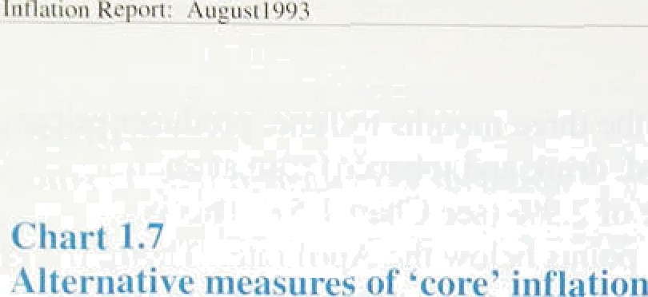and .siiiallest 15% of price changes—a ‘ti‘immefi mean’).

The measures were discussed' in the May *Report* (page IO). They are based .on the premise that it is costly to adjust pi’ices; sc› most firms do so only when

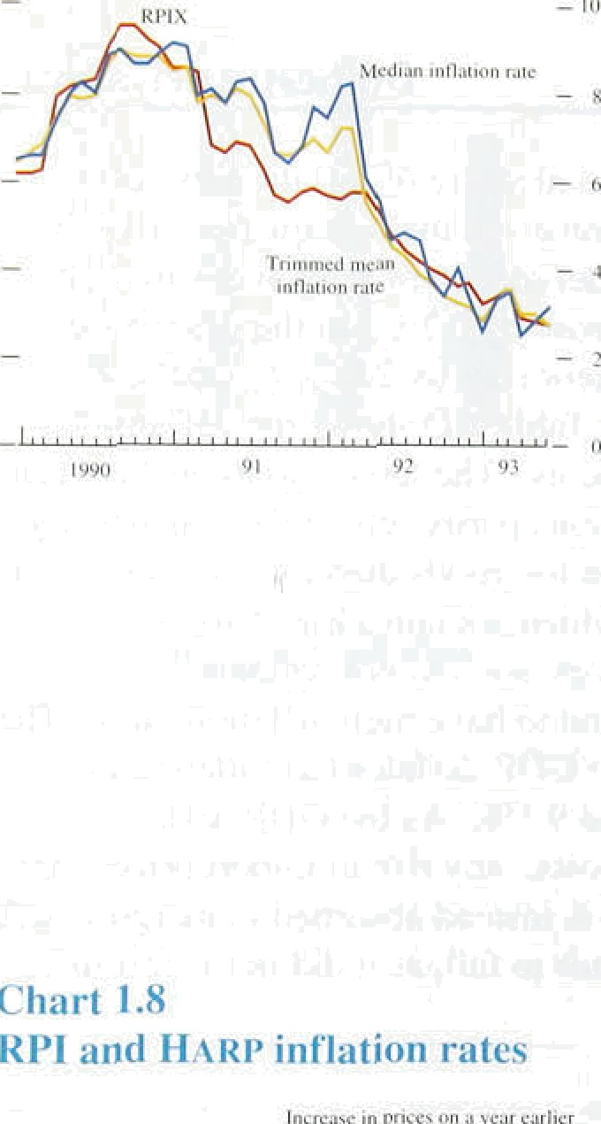actual prices deviate sufficiently front their desired level. When thei e is a large change in relative pt ices brought about by. say. an oil-shock—the effects this has on the genei-al price level will be ot’fset by small falls in itll other‘ prices if monetary policy is non-accommodating. But firms may not find it profitable to make these amâll changes. In such cii‘cumstances excluding oil prices from the price index gives a better guidel to underlying inflation. This is the i ationale for ignoring large price rises or falfs. A siini.lar effect can be achieved by looking at the median rate of inflation. As can be seen fi oin Chart I.7 both measures follow underlying inflation closely for inosr of the period.

An alternative approach to measuring core inflation has been explored in the Bank. Statistical techniques are used to identify that part of measured inflation which is caused by shocks that do not affect the level of output in the long run; we would expect most monetary shocks to fall in this category. The Bank study, which is discussed more fully in the accompanying box, suggests quite’ wide vai‘iation .in ‘core’ inflation so measured over the past five years, falling to about 2'fc in recent months.

### Other measures .of inflation

The housing adjusted RPI (HARP Index) replaces the nioi’tgage .interest component of the headline RPI with am alternative.measure of the cost of owfier-.occupied houSi.n:g.( Chart 1.8 shows that HAR!P .inflation rose from 1..8% at the tiine of the last *.Report,* to I.9% in

 April, and then fell to l..4%.,

The Tax and Price Index (TPI) has risen si.rice the.! last ftey r›rt. I.n the year to March, it .rose by 0.7%; in Aprit tire twelve-month rate increased to 1.3% but has s(nce fallen to 1.2%. The ,TPI measiires, the.change in gross incoine that‘woiild be needed to allow a household to conti!^nue purchasing.a representative’biindle of goods. It takes iñto accoiiitt.trot only changes .in prices but Also changes. to’direct taxes, and. it is‘!therefore pa*ni* ulnrly re1evant‘for clost. of !i/vifig coinparisons. The. rise in. the TPI twelve-month. i.in.flatl'on rate: since March is a



c.onsequence o’f:these direct tax' adjustments. The March 1952 'B.ufiget'.ifi.trodq0ed a!.number of'ch Ranges to the tax

(.I I For * porejletai1cd accouriJ.of.this meaJvre ios’thé.box ion.page ?'l of the.



**'Core’ inflatipn revisited**

Measuring.inflation by a price ” proposition fif macroe.conomic index,!su.cb as .the RPI,’.often theoJ: if the long-run

.leads’to difficulties i.il Ph3!llips curve.is. vertical, then

.’ identifyiñg a general upward. :!morie.tary ,shocks ,will affect moxement in priees. .core: inflation but not output in Measures of!uriderlying or the long run.

'core’ lnflation.attempt,to

fo:cus on the general price . This measure is appealing in level by smoothing short-tetm ,that no RPI component is fluctuations,'or by stripping excluded o *yriori* at any time. out indiVidual. series,.such as .Furthermore, no attempt is mortgage interest payments. made to smooth any volatility But ifi, for.example; oil price in the data since there is no i!nflation is .temporar.ily much reason to expect ‘core’

higher titan the RPI average, inflation to be stable. The should this information be choice of which movements in disregarded?. Qrl is!.an the RPI components are i.mportant corpniodity, and included in the core measure omi!ttiiig.its,‘price may lose is based only upon the effect important/inforrruiiion about of the underlying disturbances inflationary developments. on the i eal economy.

Yet the so-called ‘trimmed

inean* estimator (see The estimate is obtained using Chan l..7.)—which t›mits any n vector autoregression (FAR) obser,vation that is more than system. The observed

an arbitrary distance from the changes in the RPI measure of median inflation.rate risks inflation are affected by two this type. of:distprtion (it fs types of disturbance. The first baséd on microeconomic of these ha› no impact on real theory .whicft suggests less output in the long run; the weight ihould be:put on

outlying price changes).

.second does. An estimate of ‘core’ inflation is constructed which ‹depends only upon the first type of disturbance.

T.he.cbart shows this (long-rtiri). output-neutral

measure of inflatlon. together

with .the twelve-month changes in the .RPI and RPIX. There are a .number of .striking features. First, by this measure, ‘core’ inflation was considerably higher in the late 1980s than indicated by either of the more conventional inflation measures. Second, since 1990. ‘core’ inflation has generally been lower than the RPI or RPIX measures of inflation. Third, the

output-neutral measure peaked earlier than the two other series—responding more quickly to the monetary tightening in the period.

Fourth. there has been little sign of an upturn in ‘core’ inflation in response to sterling’s fall last autumn.

Pleasure.s of’ inf’lation

fire re.isk i ri prince un :i fi'•iir :ml ter

- i.ri

##### a measiire of core.inflation



_ nutpiii • ncuir.il

k PI

- ..»

* h»

i ont

i* yppo * o'

* .JJ

. A i

**approach; core** nflatiiin is' defined as that **component of** rneasurid infla oti that is **uncotrelated with** real output **in the loiig’run: This is**

**CDfl8lStent Wjtfl fl GOypfHOn** ’

- ›.IJ

— •..›



structure, including a new 20p lower band for income tax. This had the effect of limiting the monthly rise in the TPI .to just 0.2% between March and April last year, while the RPI rose by 1.5%. However, the 1992 budget changes have now fallen out of the twelve-month increase in the TPI, .so it has now moved broadly back into line with the RPI.

# 1 6 S

Both headline and underlying inflation have fallen sharply since the May *Report.* Three months ago there were signs of the effect of sterling’s depreciation on retail prices. Short-run inflation for those classes of goods where import penetration is high seems to have reached a peak around April and to have fallen since then. However, the falls in headline and underlying inflation .since the last *Report* probably exaggerate the decline in true underlying inflation. the introduction of the Council Tax has lowered measured inflation fn a way which is likely to prove temporary. Adjusting for this effect, inflation is slightly lower than at the time of the last *Report.*

10’ '

## 2.1 Monetar re ates

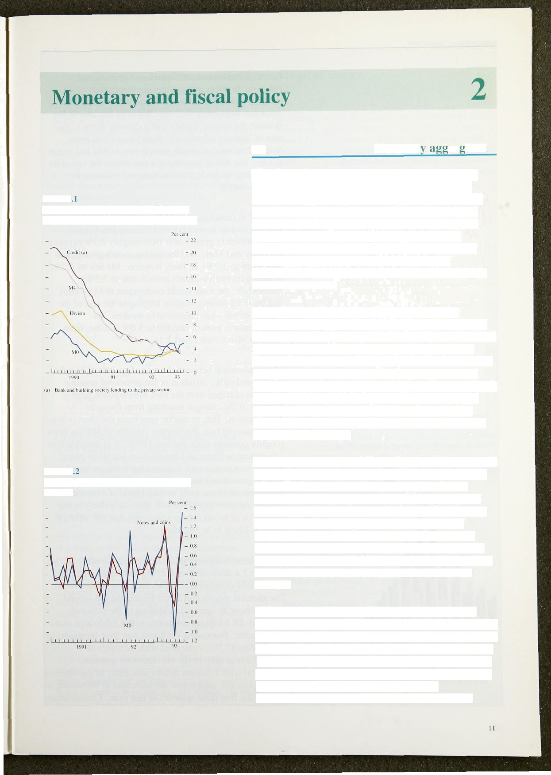

**Chart 2**

**3’welve-month growth rates of’ VIII. Md, Divisia and the credit counterparts tu M4**

**Chart 2**

**Monthly growth rates of notes and coin**

and MO

The signals from the monetary agp•regates converged slightly in the second quarter, with both narrow and broad money growing more slowly than at the time of’ the last *Report.* M0 gi’owth slowed down a little, but was still above its monitoring range ot One—49r. M4 growth picked up in May, but fell *in* June, and its twelve-month growth rate declined to 3.3%, near the bottom *of* its monitoring range of 39c—9% (see

Chart 2.1). Growth in the pt ivate sector counterpa rt of M4 remained weak.

M0 growth fluctuated during the second quarter. Monthly changes showed a modest increase in April. a substantial decline in May and increase4 in June and July for a twelve-month growth rate at 4.89 (down from 4.9% in March). Some of the month-to-month variation was due to changes in bankers’ balances and a better

picture of the underlying position is given by movements in notes and coin, the level of which fell in April and May but picked up again both in June and July (see Chart 2.2). By July the twel ve-month growth rate was 5.2% (5.1% in March).

Over the pasl year or so. M0—and particularly notes and coin—has been a good guide to turning points in retail sales. The increase in narrow money growth after September 1992 was an early indication of economic recovery, and its slowdown in April and May this year gave one of the first signals of the unevenness of recovery in consumer demand (see Chart 2.3). One advantage of M0 as a short-run indicator of economic activity is that it is available several weeks ahead of the data on retail sales and other measures of domestic **demand.**

Although the relationship between M0 and nominal income-M0 velocity—is relatively predictable (despite the fact that velocity has increased steadily over time), it is affected by changes in interest rates (see box on page 13). A fall in the opportunity cost of holding cash may result in both an increase in desired cash holdings for a given state of the ’technology’ of financial intermediation and a reduction in the rate at which

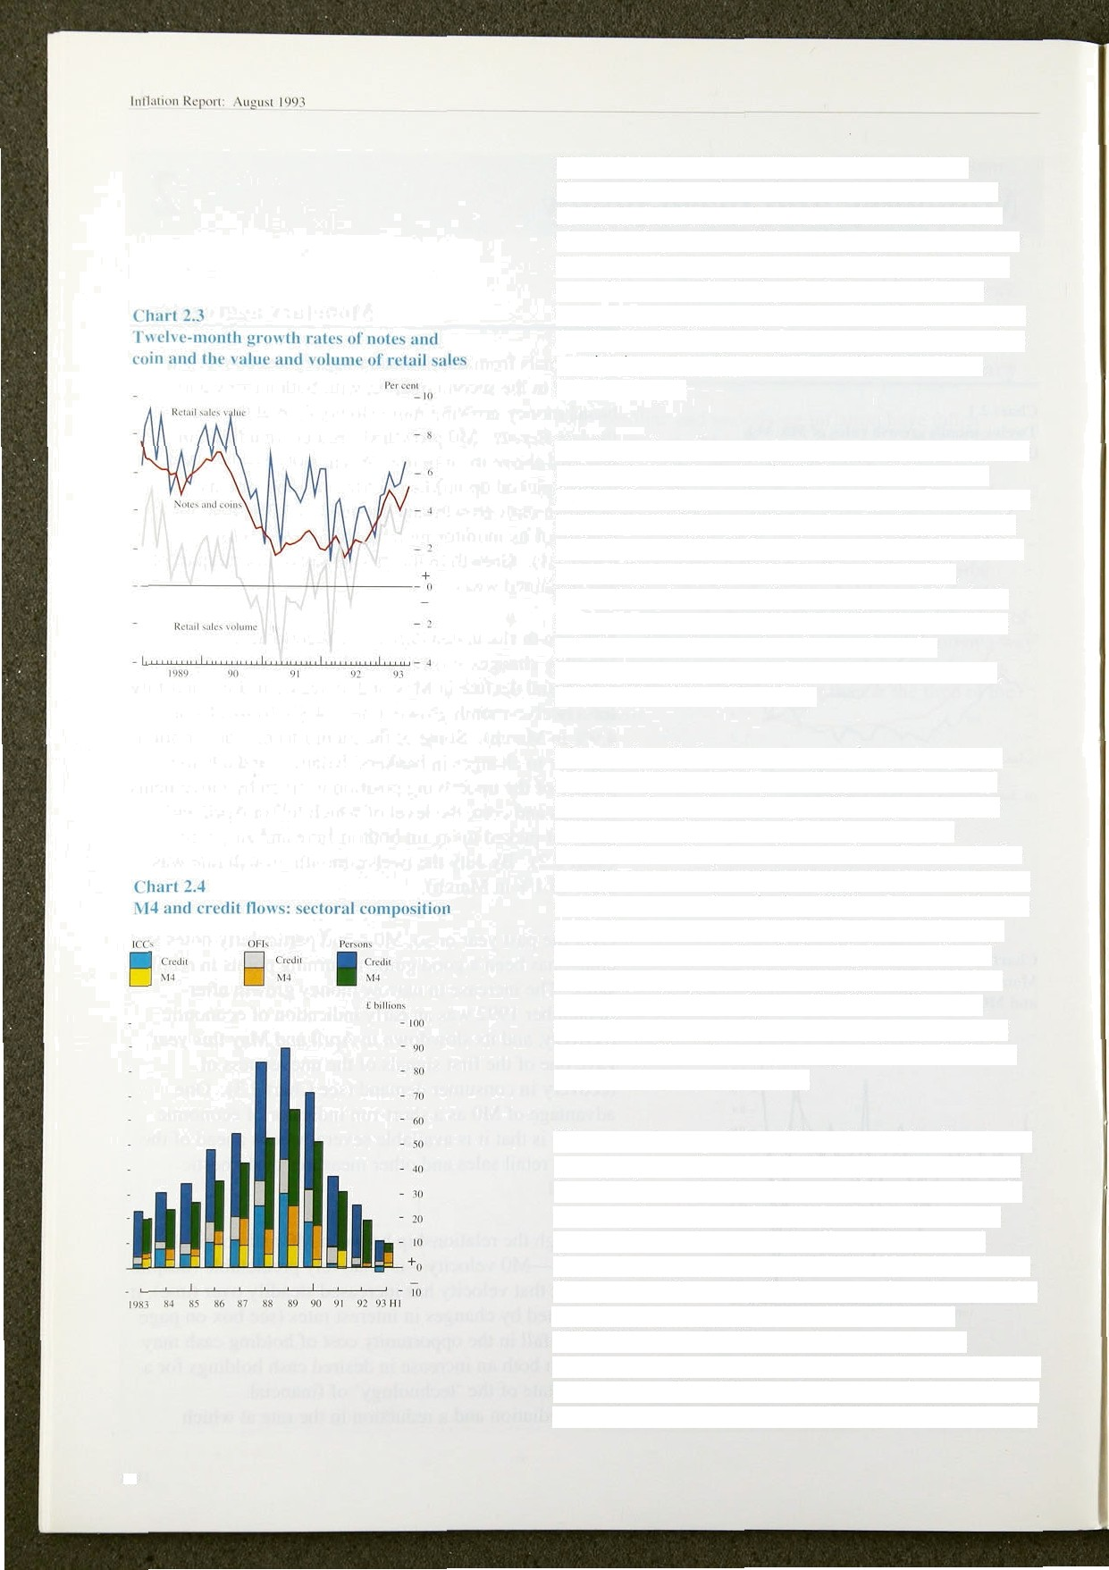financial innovations are introduced or exploited (because the incentive to innovate is reduced). As a result, the much lower level of nominal interest rates since last September will have led to an increase in the demand for narrow money and a slowing down in the rate of increase of velocity. Both factors will have boosted the twelve-month growth rate of MO and hence the fact that MO is growing at a rate above the top of its inonitorinp• range does not necessarily threaten the inflation target.

Turning to broad money (M4), its twelve-month growth rate reached its lowest point in January this year, at

3.1 %. Monthly growth was then roughly 0.5% between February and May; and the twel ve-month growth rate picked up to 3.9%. In June, however, M4 fell by 0.2%, reducing its twelve-month growth rate to 3.3%. Meanwhile, the main credit counterpart to M bank and building society sterling lending to the rest of the private sector—has continued to weaken. Its

twel ve-month growth rate fell to 3.0% in June, from 3.8% in March (see Chart 2.1).

The relationship between the rate of growth of broad money und either inflation or the growth of nominal GDP has chiinged over the past fifteen years. largely because of the changes resulting from financial liberalisation. But, as can be seen from the chart in the accompanying box, the income velocity of M4 has been roughly constant since the late 1980s. It is possible that adjustment to financial llberalisntion has taken place, leading to a more stabJe relationship between broad money growth and increases in nominal income than was apparent in the early to mid-1980s. Given the continuing slow growth in M4, there is nothing in the behaviour of broad money to suggest that the inflation target is likely to be breached.

The sectoral composition of deposits and lending shown in Chart 2.4 demonstrates that deposits and lending are less closely correlated at the sectoral level than overall. The sectoral money and credit figures for the second quarter show an increase in lending to the personal sector of £5.l billion, compared with £3,5 billion in the first quarter. Borrowing for house purchase increased by

£4.6 billion (l.5%) compared with increases of

£3.9 billion in each of the previous two quarters, consistent with a modest upturn in activity in the housing market, but still well below the increases in borrowing in each of the first three quarters of last year. Consumption

12



# The. velocity of circulation of money

The usé of a inonetary aggregate as lan interrfiediate



stock is approximately equal‘to! thé i9filation i:ate plus

:.the!:rnte of gro th of transactions.less the grovith. of velocity. If.t1ie latter term is!predictabIe; then money growth serves as an accurate indicator of acti.vity in the wider.econorljy.:arifi control of money growth, should

,ensure.t1iiit.nominal".expenditure g ows at an. appropriate rate. Tttus'it is important.to be able to explain. and preilict.changes in velocity and, in particular, iJs respdnsé tit riiorietary policy aclions.

fel*tively, !if not wñolly, predictabie when a proxy for

b‹ien following a downivard treiid. This. is because M4 includes: savings balances which ténd to move in:.line



o..have'

.with. wealth ratfier than inC.OIile:. Chore B sfiows that

M4 velocity with respect to (total gross personal sector) wealth has been more stable .than with respect to income.



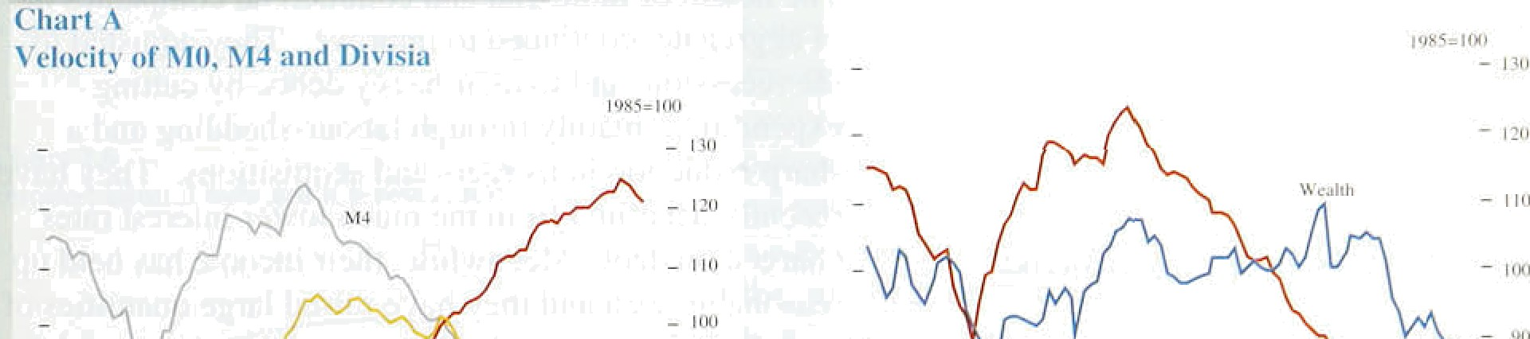

1 7 s st i s r

Cliart A plots. the.velocity o‘f M0, M4 and Di?isia

.moridy with'fespect.!to!homi.nal GDP.since 1970. M4 ' vélocify hU.been.Erratic, trending.downwards from l‘980! to 1.990 añd broadlj cfinstaiit.since then: MO velocity has.!ñeen tfendi.rig:Upwards over a much longer period,. in .fact. since..1'94ñ: Di.visia velocity has been relatively.stable over the:period,for’which data are available...

The velocity of money depends pnm ’ly..on.the cost of:holding rñoney añd on.changes. in. transactions: tccliñqlogy. .. Since M0. is not interest-beari9g, tire.cost of holdiiig M0 is siinply..the rate of retiirn:on a..



. cpmpgting asset less the retuñi on M4 holdings. Hence **M0 vel0city** reflects the interest:rate level **whereas** M4.velocity.reflects rate of return

différentials:



To the cxtent that the increase in .the wealth incoiné raiio was itself a product of financial libléralisation, a process in which the major changes aré probably behind us (such as the atioJition of excfiange coñtrols in 1979 and the increased competition between banks und building societies), we might expect.M4 income velocity to!become more stable in lathe. future„

The idea behind Dirisia riioney is to strip.out'tlie. savings components of:M4:leaYing just the'. lrañsactions elements., inclucting some.which are

.interest-bearing. H‹ince thñ stability of Oivisia Velocity.relative to MO and M4:

Changes in .the..velocity of money duri!ng.the recent recession.and he first stages’o.I the recovery have. been

„ 'particu!ar1y. difficult,to explain. MO velocity groWth has.'actual!ly'fieen:falli*g’since!the.s end qiiâi er’of. 1992, .Meaiiwhile, M4 velocity.:has.flattened off after

.e piolonged’ iownward›trend. It.is.too early to.:tel!

.whether these are permanent.or!t,émporary changes. liut th‹iy are consistent with divergences between ttie

respective determinants of money demand: iricome and the ii terest rate level for M0;: wealth anal rate of return

. differentials.for M4.

lull.ation Repori: August !**

borrowing rose.by £0.5,bill!ion. (1.2&o), in line with the. trend in retail sales over the quarter,.following a 0.7&• increase in the first quarter. Deposits, of households. rose by £2.8 billion, slightly up on the first quarter.

.Borrowing by unincorporated businessles: (which are included within the personal sector) remained practically unchanged in tlie second.quarter, whereas during the first quarter they repaint £0.7 billion of borrowing. Tliis suggests that although the pace of tlieir financial restructuring has slowed they remain unwilling to increase their borrowing.

C’hart 2.5

test iniated **total** q iiarierl›' **sterling borrou** Ing

by IC’Cs



_ - 2



The health of industrial and commercial companies has, in aggregate, continued to improve. They .adjusted, to the recession, and to their heavy debts, by cutting expenditure, mainly through labour-shedding:and a sharp reduction in mergers and acquisitions. They have recently benefited from the much lower interest rates charged on debt. Meanwhile, their income has held up reasonably well and they have raised .large quantities of new capital. As a result, these companies increased their sterling borrowing from banks and building societies by tinly fi0.6 billion during 1992 and, having repaid

£2.2 billion of such debt during the .first quarter, increased their borrowing by a further small amount in the second quarter. They also repaid £2.0 billion of foreign currency borrowing during .1992 and a further

£4.3 billion in the first half of 1993 alone., Meanwhile, they raised £8.3 billion from sterling.capital issues during 1592 and £8.2 billion in the first half of this year (see Chart 2.5). Overall, it is, clear that ioans are only one of several sources of.finance.for companies.

###### The Bank’s Divisialindex of itr3nsactions money(1) rose

_ , by 0.8&o in the second quarter, compared with.1.4& in

•* " •' " •• the .previous quarter. The annual gmwth rate. of DiVisia

reached its lowest level in the:foiuth quarter of.1.992 at 2.79r and.has. since. iiicreasedlto..3.:6 (see Chart 2:1,),. The personal sector index increased by 0.9&o:in the’ second. quarter and.the corporate.sector index..by 0.. &. The s1o.wdown in the’gro,wth of Ehvisia dimng the. second q*artér is *o’nsijtent ith thy behavio Sof M the.gfowth of which.âlso decelerateii in the second

.quarter—and M4.



**3’abIe 2A. ' Official.interest.rates'oyerseas**





Septy 1.'Dec. I h'far. 7 Mby_ 2 Au_g.



Djsmunt 3:0 3.0 3:fi ' 3.0 3.0

**’**

**.-nagaJ**

Disoouiit :3;.Z3 3:35 2.50. 2..50 2.TO

CajT ” ’ 4:10 3.90 3.20 3.20 3.30

8.75 .8Jâ' 8.00 7.25 6.75



France:

Ini‹'J-vent‹on 9.6 0.J 9.J 8.0

5.=f0.'dfly repo t0.5. 10:0 12.0 9:0

Itaiy:

Diicount t3.25 t3:0 11.5 i i.o

Advances 't4.75 14.0 12.5 12.0. 10.0



**Chart 16**

Implied annual forward **interest rates**



8



Unii&i Ringdo-





**Chart 2.7**

**UK and IP de-weighted 3-month interest rates**







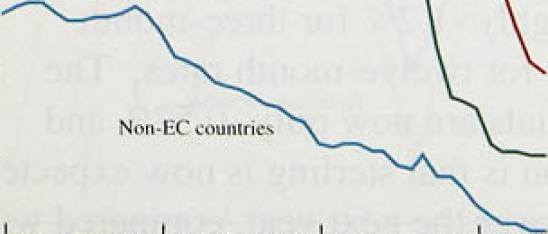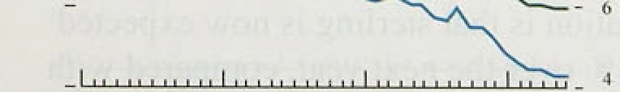

*Interest rates*

Official interest rates in the United Kingdom have not changed since the one percentage point reduction on 26 January, which prompted banks to reduce their base

rates from 7&o to 6%. In other European countries rates fell during the second quarter (see Table 2.A) and for a short period at the end of June the French intervention rate (then at 7&o) stood below the German discount rate (then 7.25a). During much of July, however, the foreign exchange markets were dominated by increasing tensions in the exchange rate mechanism. The French, Belgian and Danish currencies came under increasing pressure and, following a period of particularly turbulent conditions with all three currencies trading near their lower margins despite central bank intervention, an emergency meeting of the EC Monetary Committee was convened over the weekend of 3I July/l August. The outcome was that from 2 August the ERM bands for all currencies except the deutschmark and the Dutch guilder were widened temporarily to 159. Chart 2.6 illustrates that implied forward rates (derived from government bond yield curves) continue to show virtual parity between French and German interest rates.

Chart 2.7 shows three-month interest rates for the United Kingdom and weighted averages for EC and non-EC countries. with the weights the same as those in sterling’s effective exchange rate index. The gap between UK and EC rates is currently around two percentage points but markets expect that this gap will narrow towards the end of the year, as further falls in other EC interest rates take place.

For most of the three months since the last Depot, market expectations were that UK base rates would remain at 6& for the rest of 1993. However, the recent strengthening of sterling, particularly against the deutsehmark, has revived market expectations of a further cut in interest rates. Three-month sterling interest rates (see Chart 2.8, derived from interest rate futures prices) were expected at the beginning of August to fall to 5.3& by December, against a rate of 6% at the time of the last *Report.*

Looking further ahead, Chan 2.9 shows how implied

forward interest rates have changed. The derivation of

,these implied rates is from the gilt par yield curve. As explained in the last fiepou and the box in Section 6,

.**7 "% sent a succession of one-year interest .rates at

.fi ture ooi-year.intervals which would, if malised,

.:generate the same return..as the gilt yields over the



titration Report: August l ‹193

t’hart 2.K

Sterling interest mite rxpectationsi•'



- —7.5





Chart 2.9

Implied ***t‹›rxiaril* interest rates**







Table 2.B

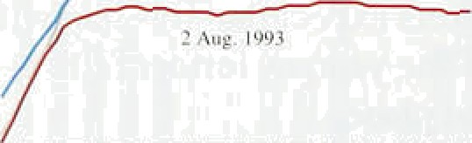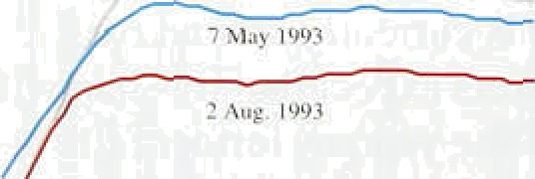

- •

**Sterling** exehttnge **rates**

equivalent maturity. The ‘no’ vote in the Danish referendum on 2. June 1992 led the market to expect a sharp rise in interest rates between .five and twelve years out. Tensions within the ERM heightened over the summer and, immediately after sterling’s membership was suspended on 16 September 1992,.the yield curve sloped up for the first time since 1988. This reflected both a fall in short,yields in anticipation of lower official interest rates and a rise in long yields,.consistent with market expectations of higher inflation.

Sinee the beginning of this .year, however, inflation. expectations have steadily been revised downwards as the credibility of the new monetary .framework has increased, although implied forward rates at the



are still slightly higher than before departure from the ERM. The yield curve implies that interest rates are expected to rise to around 8.5&o, approximately 100 basis points lower than in May and 150 basis points lower than in February. This continuous improvement in

i‹› expectations is encouraging, but it is not clear that

, expectations are yet consistent with the inflation target.

*T/ie exc’liange i ate*

The effective index for sterling has fluctuated in a narrow range around 80 to .81 since th*e* last *Report,* it stood at .81.4 on 2 August, against 80.9 then. Sterling has fallen by I 0% since its suspension from the ERM; within this the fall against EC countries is 4% and

non-EC countries 16%,.

During May and June as weakened.by occasional political uncertainty, but it has strengthened over the past month against a particularly weak deutschmark. Sterling has fallen.against the dollar, which has been underpinned by a belief that the growth prospects for the United States are relatively strong.



Sierling ERi 90.9

Ocutschmart *.78

ECU 138



79.6 77.7 80.9 81.4

I .52 I .45 I.SB. 1.49

2.4S 2.40 ’ 249. 256

IIO' I@ 1 II J67

Chart 2.10 compares the short te:rm,.yi

United Kingdom with a sirriilar yield curve for ‘world’ interest St



differential between the two curves. In the last *Aeport*

the differential was roughly -1.2%/for:three-month. interest rates an‹i -0.6. for twelve-month rates. The corresponding .differentials are now only -0.52 and

-0.13 . The: imp1 tion, is..that sterling is.now expd cte

u ' 13

pbctad se of 0.6J et *thence of the 1 Report.*









— 6.ti



.U& eo‹te•wéighted inu'resi mic dilTe •nIicI

 

- -0.6

 12-morib

**Table 2.C**

**General government financial balances and debt levels iii the G7 countries**



|  |  |  |  |  |  |  |
| --- | --- | --- | --- | --- | --- | --- |
|  | ]9gl | 19g2 | 1991 | t99* | 199.1 | 1992 |
| United'Siates | -3.4 | -4.7 | - l.1 | -2.5 | §Q.g | 63.z |
| G.crtoaay | -3:2 | -2.8 | - I:0 | -0. I | 4g,g | 43,2 |
| ’;Iu#y.’ | -10.2 | ..9.5 | -0:5 | 1.4 | 104:0 | l 68,1 |





_+



# 2 2 F sca

The Budget forecast put the PSBR for 1993/94 at arou nd

£50 billion, some 89 of GDP. Part of this deficit is ‘cyclical’ the result of the economy being below its long-run growth path. As the economy recovers. reducing unemployment-related spending and boosting tax revenues, the deficit will au tomatically decline.

Nevertheless, projections in the 1993/94 Financial

Statement and Budget Report (FSBR) show the PSBR remaining as high .as £30 billion, or 3'/4% of GDP. in l997f98. The ratio of debt to GDP is. on current policies, likely to increase for some years to come.

Although large, the United Kingdom’s overall deficit in 1992 was similar to Canada’s and much less than Italy’s (Table 2.C). However, the primary deficit—the deficit excluding debt interest payments—was much larger than in any other G7 country. This is important, because a primary deficit means that the ratio of debt to GDP is likely to continue rising until the deficit is eliminated.

An alternative way of measuring the deficit is to adjust the PSBR for inflation. Inflation erodes the real value of the outstanding stock of public debt. A simple inflation adjustment, shown in Chart 2.11. illustrates the effect of inflation on the real value of outstanding public sector debt. High inflation during the 1970s sharply reduced the real value of debt. more than offsetting the effect of large PSBRs. By contrast, lower rates of innation in recent years, together with the smaller size of the debt in relation to GDP, have all but eliminated the discrepancy between the actual and

inflation-adjusted PSBR. As a consequence. the ’inflation-adjusted deficit is now higher than at any time since the second world war.

Deficits have to be financed and the borrowing incurs interest which must be paid in future, thereby adding to later deficits. This cumulative effect can damage the credibility of anti-inflationary policies, by increasing the potential benefits to the government of financing the deficit by money creation at some time in the future. IN the inflation target is to be met, the real burden of debt cannot be,redueed by unexpected inflation, as was the case i:n the 1970s, but must be tackled by bringing rtwgnuU and:eXpenditures closer to balance, The Government has already annouriced a number of

##### .measutes,to generate sizab1e:increased revenues ovet the next three years.

This, together with continued adherence to existing government spending plans, wiI1 help to bring about a reduction in the deficit over the medium term. Further fiscal action may be required as the Government has recognised.

18



**Table 3.A**

**Expmditure,components of GDP at constant**

###### In the short run, real demand and output affect the rate at which inflation adjusts to the level implied by the underlying monetary stance. The existence of an ‘output

.gap’—when output is below its trend—will, other things

being equal, tend to reduce inflation. That is indeed what has happened over the past three years. A gradual recovery in demand and output is now under way, but the output gap may take several years to close.

**Percentage:changes**

Consumers ex#•nd‹iure



PkbJic' consumption

-2.6

1.4



Totat fioal.demand



**GDPlb)**

Quan¿rjy

**changes**

0.5



0.8

, g



**wbIve-month**



2.3

6.0





0i9

3.1 Demand

The significant easing of monetary policy, especially since last autumn, should result in a gradual increase in

.demand and output relative to trend. The reduction in interest rates will encourage growth in domestic demand. and the depreciation of sterling will boost demand for tradable goods—both for exports and for those domestic goods that compete with imports.

**Chart 3.1**

**.Contributions to the growth in GDP**

(1902 Q2-93 Q1)

###### In the year to 1993 Q1, the volume of total final demand rose by 1.7&r. This consisted of a 0.4% increase in domestic demand and a 6.0% rise in exports of goods and services; imports rose less y, by 3.69‹ (see Table 3.A). However, because consumer spending is

q„q such a large proportion of GDP, it contributed more than new exports to the growth in total expenditure between

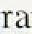

the trough in activity (1992 and the first quarter of

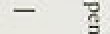

_

-t



- 0%



— .0.8'

##### this year (see Chart 3.1).(' Total investment has also risen, mcluding public.sector investment. But it is striking that public consumption fell by no less than 2.6& in a year, largely as a result of the fall in defence procurement. Although part of the increase in total demand has been met through a rundown in stocks,

output in the economy as a whole had risen 1% above its ugh by the first quarter of this year.



The volume of personal expenditure has been rising stnadily since its trough in the first lquarter of last year.

’. .Consumers’ expenditure increased by 0.5% in 1993 Q1 and by.2.3& in the year to the fast quarter. The volume



1 nl1:itioe Repurr: Augur t003



I’ersi›nul scctnr savings and **b‹irrow'ing**

} p ' *° ' ' Per ccci y

to — j

* ’ — — o

'iavia • r-din i lrfi h:ind cii ley



i riuiu' l ri'incl *sc*ic.‘i nvcneil i





**Personal secl**or terming and fi nancial **deficit**





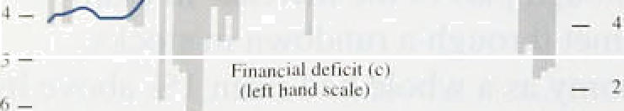

of retail sales (40% of total persongl spending) increased. by ,0.5% in 1993 Q2 after growthlof l.7&a in the first quarter. Until the autumn„ the recovetry iii cqnsqmer spending came from an increase in! personal disposable. income, while the personal saving.ratio continued to rise. The saving ratio has been higher than might have been expected, given the large falls in both nominal interest rates and price inflation over the past three years. This almost certainly reflects the unprecedented

###### .increase in personal indebtedness during the second half

of the 1980s.

Over the last decade, changes in the personal saving ratio have normally led to changes in borrowing from banks and building societies rather than changes in holdings of financial assets. Until last autumn the rise in the saving ratio was matched by a decline in borrowing relative to disposable incomes (see Chart 3.2). .Falling house prices, however, meant that capital gearing outstanding borrowing as a proportion of financial and. physical assets—continued to rise (Chart 3.3). The number of people with negative equfty peaked at

1.8 million in the first quarter of this year, according to Bank calculations (using the Halifax Building Society’s index of house prices)—their negative equity amounted to nearly £12 billion (using the Department of the Environment’s house price index gives smaller numbers, 1 million and £5.6 billion respectively). But house prices have now stabilised, and the volume of transactions in the housing market has been on an

upw d trend since the end of last year. As a result; the number of home-owners with negative equity is estimated to have fallen to 1.4 million in the second

.quarter (base‹i on the Halifax price index), with its Value almost one quarter lower.

Although perslonal sector deñts have Attained at récord levels relative to both assets.an‹i i.ncome, the easing..of monetary policy has meant,that the costs of financing outstanding debts have.fa!llen sharply. Income..

##### .gearing—gross interest payments as a proportion‘of

.disposable income—fell.from a pea of 14.3% !in

##### 1fi90 Q21to.’about 8'fi&a i.n l993!,Ql. Since.borrowi.fig by the. personal!sector exceeds.,its deposits„(by £38.d„bi11ion

:at the'.end of 1992), lower interest.rates wiiLa1’so have

boostéd the.sector’s net i!ncome.

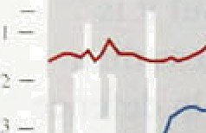

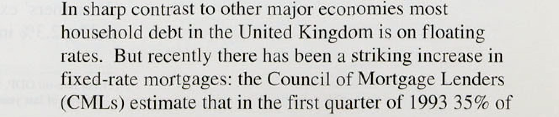



a nongages were on a fixed-rate basis. Such mortgages account for an estimated 79o—8% of the value

of all *outstanding* mortgages.

**Chart 3.4**

**Corporate sector gearing and financial deficit**





*.Investment and stoc'khtii1diii(*

The volume of investment in the economy as g whole reached a trough in the second quaner of last year Between then and the first quarter of 1993 it rose by 2.4'7o. Within that total, the volume of public **Sector**

investment has grown strongly—up by 9.6% last year— and should continue to do so this year. This is partly because of the relaxation of the rules for use of local authority capital receipts announced in last year’s Autumn Statement. Across the whole economy, stOCJS fell by an estimated £600 million and £800 mfllioC (1985 prices) in 1992 Q4 and 1993 QI respectively. Clearly this destocking cannot continue for much longer: the CBI monthly trends enquiry shows that during the second quarter the balance of firms with more than adequate stocks of finished goods was at its lowest for 12 months.

In 1992, business sector investment as a percentage of GDP was nearly three percentage points higher than in its prrevious trough in 1983. But higher investment has

* '° been mirrored by a larger financial deficit in the recent



recession (Chart 3.4). The deficit was virtually

##### eliminated in the first quarter, but the effects of

* prolonged periods of large financial deficits and

###### , _ borrowing requirements may continue to limit growth in

company spending for some time. This is because steady increases in internal funds may still be insufficient to finance marked increases in investment

5 from levels which are already high by historical standards and, following the rapid increases in debt in the late 1980s, firms may be reluctant to run large financial deficits again.



The CBI’s July Industrial Trends Survey is consistent with a slow recovery in investment. The balance of firms expecting to increase investment in plant and machinery over the next twelve months was still negative, at -3%, but this compares with a balance of

-8% in the April survey, and more firms reported that plant capacity is acting as a constraint on production. But thé.balance of firms planning to increase investment in’buildings was -20a, unchanged from the previous

''„‘ ’}', .’. ’„ ". ,' **The.latest.CBI.**data reveiil .that only a balance of 11%.of

###### "“ " " ’" ' '’ fritis are more optimistic about their business situation,



Inflation ReN rt’ Aufiu. sr l0*J3

_ _ _

compared with 31a in April. Export prospects are! a major cause of reduced optimism; a balance of 1% of firms expect the volume of export.orders to fall in .the next four months. Other.data suggest that business: confidence continues to increase. The Dun.and Bradstreet Survey across all industries shows sales expectations continuing to improve slowly. The British Chambers of Corijjnerce Survey reported a slight increase in the balance of firms expecting profitability to increase in the next quarter. In the financial sector, the CBI/Coopers and Lybrand Survey for the second quarter shows that a large balance (+28%) of firms are more optimistic about business prospects than they were three months earlier. Optimism also appears to be growing in construction according to the Building Employers' Confederation Survey.



UK trade volumes in non-nil gonds (excluding



Percentage changes



j9g2 QI— 1992 Qñ- 1992 Qi — 1902 Q3—

1992 Q3 1993 QI 1992 Q3 1993 QI

Provisional figures on UK trade with all countries are now available for I993 .Q1. The data suggest that the impact of lasl year’s sterling depreciation along with the United Kindom’s superior performance on unit costs has begun to feed through into higher net export volumes: Between the third quarter of last year.and the first quarter of this, exports of all goods and services increased by 4.49 in real terms and imports by only 1.29c. In the previous six months, the import total grew by 2.3% compared with 1.69c for exports. Although exporters have taken more than half of .the gains from depreciation .in hig foreign currency prices of non-oil exports were around 59 lower in

1993 Ql than in 1992 Q3, Consequently, export volumes of goods and services, excluding oil, rose by



**N‹›n-EC**

0.3 0.9 3.1 -0:3

4.3 7.3 4.5 8.7

2.1 4.I 3.7 3:6

4.4  1.2.

5% between 1992 Q3 and 1993 Q1 aftet declining by 0.3% between 1992 Q1 .and 1992 Q3.

Trade with the EC has grown much more slowly than with.non-EC clountries since the autumn (see Table 3.B). Whereas exports to the non-RC area lose by 7.3% .over the period, those to the EC increased ñy only 0.9& . Part of the discrepancy can be explained by the fact that. between 1992 Q3 and t993 Q1 sterling fell 17’/z*%* against the non-HC area brit by only 10'/i against.the EC. Also demand has been .growing much more slowly iii the EC than elsewhere in the’wor1d. To take one









**Cltart** 3 5



**tmp rt tratfon* ’m the U9ited Kipgdoui**

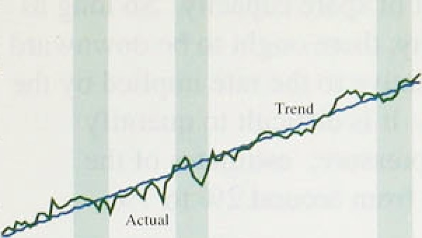



— ig Ié.^



**Cbarti3.6**

Import penetrationt•i in France



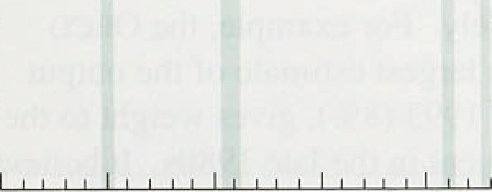

- 0

**Chart 3.7**

Import.penetratlon‹•› in **Germany**





- 20:



quarter; whereas in Germany it fell by 2.0&o and 3.5% respectively. Domestic demand also fell during the second.half of last year in Italy (-1.6%) and rose only

.slightly in France (0.17•). Although demand is likely to

.grow.quite strongly in North America and the developing world for the rest of this year, it is likely tO be flat in Japan and to fall in continental Europe.

Further strong growth of UK export vOlUmes wiI1 therefore depend on exporters taking a larger share of a

sluggish world market.

Even though sterling has depreciated furthest against non-EC currencies, non-oil imports *o(* goods (excluding erratics) from outside the EC rose rapidly (8.7%) between 1992 Q3 and 1993 Q1, while imports from the EC fell slightly (0.3%). The United Kingdom’s visible balance with the EC has therefore improved slightly since the autumn despite a deterioration in the terms of trade and a decline in demand on the Continent. More recent data available for trade with countries *outside* the EC show that, during the second quarter, and excluding oil and erratic items, the volume of both exports to and imports from them have risen significantly. The particularly strong growth in exports meant that net trade volumes made a further positive contribution to growth.

Usually during a recession, imports decline more rapidly than total final demand. During the recent recession, import penetration—import volumes of non-oil goods and services as a proportion of total final demand— continued to increase (see Chan 3.5). Despite the improvement in UK competitiveness since last autumn, the rise in penetration has continued; by 1993 Q1,

non-oil import volumes represented 24&o of final derriand. But import penetration has also increased in Franc at a rate similar to Britain’s since the

0s—and Germany (see Charts 3.6 and 3.7).

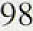

# 3 2 O and the out t a

##### GDP rose by 0.4& in the first quarter of 1993 (and by

0.7&, excluding oil, the largest quarterly increase in

##### .four years). Chart 3.8 shows that manufacturing recoxered particularly strongly, but the increase was broadly based; industrial production rose by 0.2%, and service,sector output by 0.7%. The preliminary estimate of GDP.in the second quarter suggests that the recovery has cofitinued, wftii a further rise of 0.5% in non-oil output.



The CBI Quarterly Survey showed that the proportion of manufacturing companies working below capacity fell from 73% in January to 639a in July, but this still points to a large amount of spare capacity. So.long as



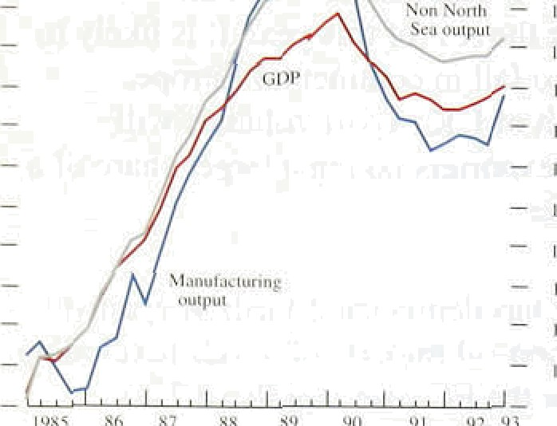„ firms .have spare capacity, there ought to be downward pressure on inflation .relative..to the rate implied. by the monetary policy stance. It is difficult to quantify current disinflationary pressure: estimates of thee

° current output gap vary from amund 2% to 7& .



**(7utyut** gap **estimated**







fihazt W. IO

**Output gay estimates**



###### Charts 3.9 and 3.10 show four different estimates of the “ output gap. The first is one derived by a purely

statistical method of establishing the.trend of quarterly

„ non-oil output from 1955.( I It generates a trend which changes smoothly from quarter to quarter. The second approach Is based on econometric estimates of the trend growth rate between those quarters in which the economy is believed to have been on trend (the

so-called ‘split-time-trend’ approach). The estimated trend growth rate changes discretely and less frequently than under the first method. The third measure uses the CSO’s coincident indicator of economic activity to determine when output was on tren‹i, and the average growth rate between these periods is used as the estimate of trend growth. The fourth measure is the OECD s output gap estimate which is derived from a model of the.economy's supply side.

The estimates vary widely. For example, the OEcD measure. which has the largest estimate of the output gap at the beginning of 1993 (89c), gives weightlto the rapid growth of investment iil the late .1980s. It believes that this created substantial spare productive capacity despite some, scrapping of obsolete capital.during the. recession, By contrast, the statistical trend produces an output gap of about 2'/i%; and .the split-time-trend method a gap of just over 4%, about:the.lsame as in the .

" lear1y l980s. The coincident indicator estimate.lies. ' .between the split-time-trend.measure and. that of the

OECD.

 





# r4un

E s a d ettle e ts

**Chart4.l**

**Underlying earnings growth**



W.hde.:'›ronemy





- - 6

 92.







Pay inflation continues to fall. In the economy as a whole,the twelve-month rise in earnings declined from

.4.3& in February to 3.79a in May. Earnings in services

have been growing more slowly—by 2.9% in the year to May. The Employment Department’s measure of the underlying increase in whole economy earnings declined from 4'/i9 in February to 4% in March and April and 3’/›&o in May (see Chart 4.1). In contrast, the underlying annual rise in earnings in manufacturing has remained at 5.0% since February.

Wage settlements have also been falling (the box on page 27 discusses the relationship between settlements and earnings). According to the Industrial Relations Services (IRS) measure. the median whole economy settlement declined from 3.0% in the first quarter to 2.0% in the second. The decline is attributable to lower private sector settlements, since public sector

settlements have remained at about l.5%. IRS estimates that the median private sector pay rise fell from 2.75% in the three months ending in April to 2.39r in the three months to June. However, another pay research group, Incomes Data Services, reports that private sector settlements have stabilised in recent months.

In the services sector, the settlements surveyed by the CBI averaged 2.5% in the three months February-April. In manufacturing, .CBI figures show that settlements averaged 2.1% in the same period, the lowest figure recorded by the CBI Pay Databank since it was started in 1977.

IRS reports that there is no sign of a decline in the number of settlements which are being postponed.

.However, the **.CBI** reports that the proportion of manufacturing firms which had postponed .settlements for six months or more fell from 26.3% in January to

.21.7% **.in April,** with ,companies in services slightly **more**

likely than manufacturing to postpone. These deferrals

.depress,current earnings growth, and may therefore paint a mlGleading picture: where the subsequent increase has been agreed at the time,of postponement, the .pay increases eventually granted tend to be above the median settlement at'the,time.of;teferial. Some firms have

introduced bonus schemes or lump sum payments as partial compensation for postponing increases in basic pay.

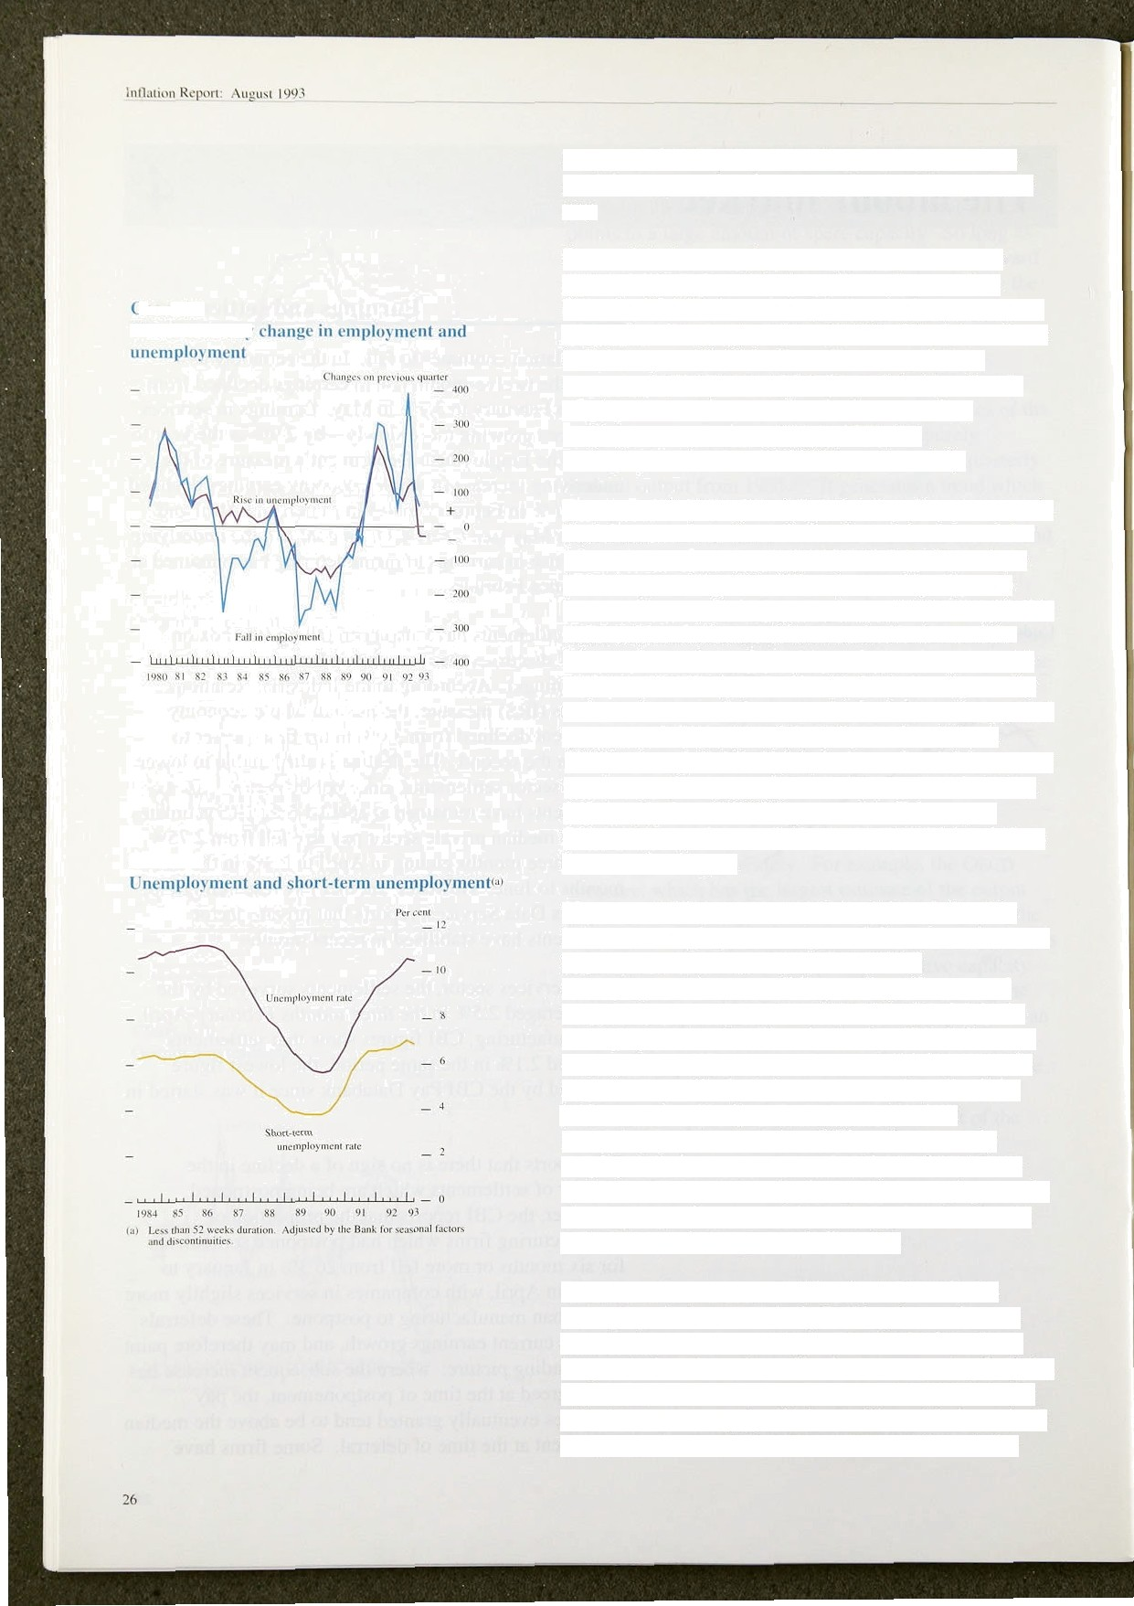

\\ hi›1c ec‹iiuiiiii

£“hiirl 1.3

Recent falls in unemployment could mean that one restraint on pay is weakening. Unemployment has fallen by 83,100 since the beginning of the year and the jobless rate has declined from 10.69 of the labour force in February to 10.4% in June. But recent falls in unemployment have not yet been matched by rises in employment—whereas, after the last recession, employment started growing in 1983, but unemployment rose until 1986 (see Chart 4.2).

This makes it difficult *to* judge the changing pressures in the labour market. Some indication of the demand for labour comes from overtime in manufacturing, where hours increased by 0.3 million (seasonally adjusted) between January and May. Vacancy figures also provide some evidence of a small increase in the demand for labour: from a low of 111,500 in September 1992, the number of unfilled vacancies at Job Centres (generally estimated to record about one third of all vacancies) rose to l 23,600 in May (the highest figure since March

199 I)—though it fell slightly in June. In addition, hours lost as a result of short-time working in manufacturing fell sharply from 760.000 per week in February to 260,000 per week in May, the second lowest level since the recession began.

The May *Inflation Report* examined the relationship between unemployment and growth in real earnings and settlements. The evidence suggested that unemployment has a small depressing effect on real wages. It is sometimes argued thht it Is the change in unemployment, rather than the level, which influences wage growth. When unemployment ih rising, those in work are more likely to become unemployed and the jobless are less likely to find a job. But when unemployment is constant or falling, the currently employed feel more secure in their jobs. Some wage equations incorporate only changes in unemployment in the wage equation; research in the Bank suggests that both levels and changes are influential.

From all this research, one thing is clear: only the unemployed who are actively looking for work exert downward pressure on wages. Those who have been long out of work are less effective at competing for jobs, and so should be given less weight in a measure of the effective excess supply of labour. Chart 4.3 shows both the conventional unemployment rate and the rate for



Wage 4gttlements are often thought to ‘lead’. earnings growth because they are inbetently forward-lookirrg:



:settiements determineithe, pay of the settlement.group for'

the ctiinirig period (one year iihead ih:the case of.annual ,

settlemefits). Do:sealements data help to predict future'

earnings growth? The answer Auld help to assess — — ' whether earnings growth might. decline furtfier iñ



ii i i i

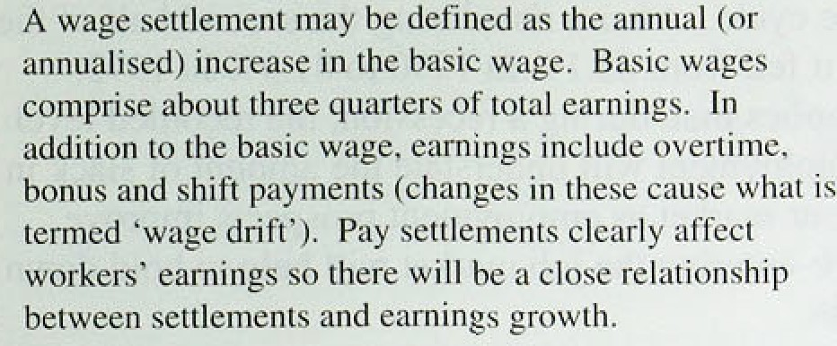t””ht rt R



:Speéifically; seitlemerits data.might.appear to foreshadow s 1aiiur*ictu ring earrings g r‹ru t li and set Elements earnings growth becausé of diTferences, between the r„‹„„„„,. , .,.,:..„,., ,.„ ‹ , .‹. sainplesisurveyed when actua!l earnings and scttlements

data are collected. . The.CBJ; wliich. is the! source or — '•

,manufacturing settle;rteiits data,earid IRS, which covcr the

whole economy., siirvey'those groups which they know to ,

be settling currently. ..Séttlements data therefore capture

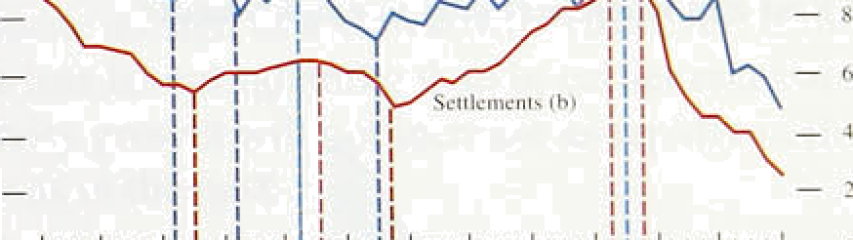thetwage increase: of only thee.e.who. settle in the..curi:ent _“ ” period... In contrast,.average earnings figures refer to .all — ”  ivnrkers in the economy,!so:the annual increase .in



!inattet when they tast,settléd:. This: means: that earnin=ps

: figures should.represent a weighted:.average of settlements data oxer.the past year;.and!.ttiat ,past settle;nienfs;affect current earnings..’The weights ori tags. of senlements will reflect the proportion of the workforce settling id .tlie.particular period.



anal B suggest tliat turning points in settlemeiits. knd. Earnings ‹ian:a‹ijiist.quickly .to shocks to any of these



lag.or 4ead):roughly. coinéf if'anyttiing, earriings! into account.coiiiporiiints .of those. shocks wliich are growth.Appears to lead.s ttleméiiits. For examplé; in percéive‹i astpiprmanent. For example, overtime hours

1990; whole.economy earnings growth..peake0 ' i ñ August;. And.ply will tend!to nse .w.hen ouJut rites.in response to . between two.ând four monthe %fore settlements. a positik:e deriian‹i..shock, assumin'g..firms find it difficult Statistical tests ‹ionfirni'tfii impressions From..the charts: on costly to hire .labour.. In these conditions, if the. shock '

is perceived to tie permanenl, subsequent wage'

09e explañation for these counterintuitiJe findings might settléments are likely to be higher since fries will need to bé that iri‘negoadting current sett1em‹ints, negotiators pay more to recruit ati‹i retain labout, and the firm's

frame in ipind roéent earnings ini:teases as easilj ’’ ..workforce ,will bé in a relatively strong bargairiing obsé atile iiiilieaiors of south 'gofng rate’ on which they ,posifion.

. .@BSC ''l£.WBgC 'fi fit)CDtRñt. ’ ’ ’'

.’ This riidy e›tplain why earnings appear to. lead

*F*irm*s* can **react** tp uiumticipated evot i which **occñr** settlements. The .implication is that attention should bei bet'itesn 8ettlh ten(datas by a‹ijiiating oâr0iiigs. pai‹i to inéreases iii’oiher etc;inénts.of pay'in addition to

**.Settiemenie are..neg**'otiamd **only** perioditall.y:wnarmally settlements when piedicting settlinñents:**an‹i** e ings.

**oooe«,year: They** will **be baaed** rim negonators ! inflation.



lnfla‹in1› Rcyt*rt: August I991

€"hart 4.4



those! out.of work for less than a year.(the.number of short-term unemployed.has been adjusted as far:as possible to be consistent with..the current definition of unemployment). The:.short-term jobless.’rate:at the end of .1992 was probably higher than. at any time!in the 1980s, which helps .to explain why pay inflation has

###### , , „, , been falling rapidly an‹i has reached its lowest level for

”' 26 years.

* — '•° Furthermore, the panicipation rate—the proportion of
  + •* people of working age in work or seeking it—moves

* with the cycle. After a rise.during the second .half of the

'* 1980s, it *leIl* from 83,.loo in 1950 to 8!1.9% in 1992.

* + "" This implies that, during a recession, the recorded level

•' of unemployment will understate ’the amou:nt of slack.in

“ the labour market as..employment prospects improve.

Those re-entering the job market will help to hold down

' pay rates.

 The effectiveness of the unemployed in finding! work may be reduced by ‘regional mismatch’—imbalances

between the distribution of vacancies and unemployed workers across the country. As Chart 4.4 shows, mismatch moves .cyclically, increasing with rising unemployment. However, it is now well below its level in 1984 and .198,7, when unemployment was similarly

t’hart 4.S

S‹iut1i **East and** whole **economy unemptoyment'•'**

high, so upward wage pressure from mrsmatch should be less than it was then. Chart 4.5 shows that the share of unemployment in tire South East rose strongly during the recent recession. Any .disproportionate1i!ncrease in

unemployment in the lsouth East appears temporarily to. reduce the growth rate of real wages.

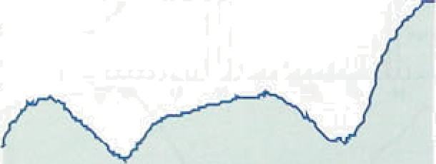

.

- - 25

— °• Skill shortages are often cited by managers as a factor which tends to increase:wages. The July. CBI Industrial Trends.Survey found that [ñ@o.of](mailto:ñ@o.of) finns considered .that.a

i• lack of skilled.labour was lfmi.ting.!their output.

Although this was .higher than.the:Jañuary.figure„sktl1 shortages have been a problem for under .l0âa of firms for eleven successive quarters.

.In summary, recent falls in unemp}oymefit may overstate. the true tightening of the lai›our market. There are still strong dowiiward pressures.on..the rate.of pay increases; stemm ring.from,.firms’ unwil1.ingness to raise prices. while demand is so uneven; and a high level .of

sho.rt-term unemployment. These factors are likely to

subñue,earnings. growth dunng tñe,nextcyear.

28



**Table id.A**

**Contributions of earningsland productivltr to unit wage costs**



1992 Ql -1.3 2.9 1.6



QJ -0.4 -.B 25

4 0.2 -3.0, :3.2



J.9 7.5

6:5 4.1

8:8 7.0

6.6 4:5.

3:2 2.8

3'.4 2.0

3.0 -1.0

1991 -’i:2 -6:6

j9g2 -0,7 -5.3

l992 Q1 - I .9 -* 6

Q2 -U.7 -5.T

Q3 -0.7 -4.7



1. 2 L bot

J.3

'\. I 4.9

4.fi

4.2

6.3



#### i

9.4

8.2

6.6

8.6

6,0

6.2

5.7

4.8

7.0



I,S

3,6

1,2

1.9



#### s

Chart 4.6

**RPE inflation and unit wage cost gruwth**





When ftrms find it cheap and easy to adjust the size of their workforces, employment changes coincide closely with changes in output. This is in contrast to the UK experience in past recessions, when employers ‘hoarded’ labour. During this recession productivity growth has been higher than in previous downturns, which is consistent with the labour market being more flexible.

The twelve-month growth of productivity in the economy as a whole continued to increase in the first i}uarter, reaching 4%. In manufacturing, productivity

,› was 8:.09o higher than in 1992 Ql, and later monthly

, figures show no sign of a slowdown. However, if there has been less .labour hoarding than in earlier recessions, productivity growth will not increase as rapidly in this recovery as in the past.

_ RPI inflation — 4

- 2





The strong.growth in productivity combined with the

.low growth in earnings produced a remarkable outturn for unit wage costs (see Table 4.A). In manufacturing, wages and salaries per unit of output fell over 5.0% in the year to May 1993. Whole economy unit wage costs

also fell, by 1.0% in the year to 1993 Ql (see Chart 4.b). This pattern is unlikely to be repeated, but the growth of unit,wage costs is likely to remain low for some time.



 **Price dynamics**



**5.1 External inf’Iuences on inflation**

CtHTnnodity pi’ices affect domestic inflation in two ways.

First, .ind dii ectly, through changes in the prices of iinptD ts of’ i"aw iiiaterials and foods; tend second, indii’ectl y. via their influence on the foi’cign currency prices of goods and services pi’oduced by the United Kingdom’s trading p‹utners, which in turn affect UK iiiipoi t prices. The impact on domestic inflation need nt›t persist, unless the change is accommodated by domestic mt›netary policy.

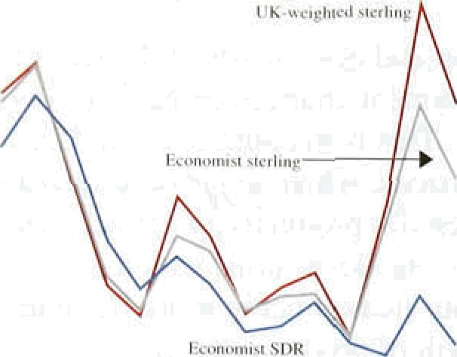

The U K-weighted non-oil corrimodities index rose by 41 % between 1992 Q3 and 1 993 Q I, compared with a rise of 2S9o in the Econoin.ist index * (both measui’ed in sterling terms). In 1 993 Q2, ,both indices fell back the Economist index by 7%, and the UK index by 8%. The

 divergence in the indices partly i’eflects the recent sharp rise and subsequent fall of timber prices (resulting from concerns about US environmental policy affecting prtiduction), which have a higher weight in the UK index. Both indices have weakened recently, perhaps because Of’ the gi’owth in stockpiles .of metals.

Although oil prices in 1993 Q2 were marginally .above ' 1993 Q I levels, they have dropped lslightly sinee the

June tOPEC meeting, ivhich agreed to roll over the second quarter production ceiling of 23..6 million barrels a day. Output in that quarter was above ut›ta, and it is significant that both Kuwait anal Iraq refused to accept thei.r quo.tas at the lime meeti.ng:.

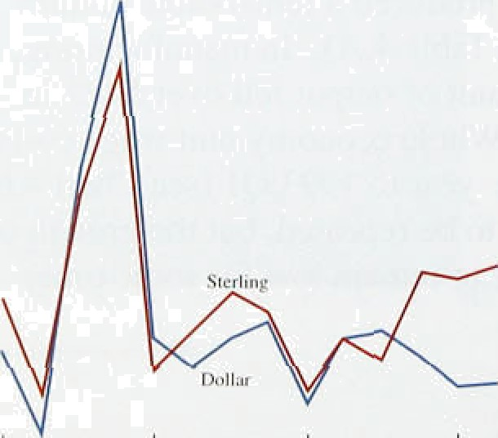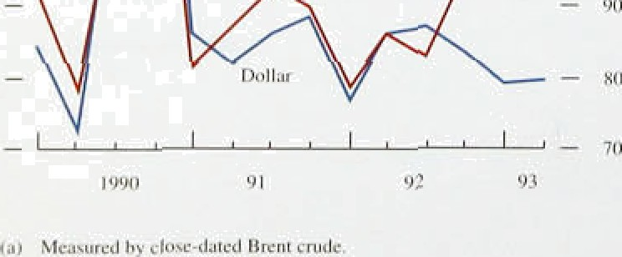

_

""

With the continued recovery in the .United States likely to be offset by weakness in Europe and Japan, i!t seems that .commodity prices will not'rise sign!ifiicant1y as a result!of increased demand. Supply-side consi‹ierations—=for.example„.the recent. failure of tnl!ks on price stipport mechariisifis for Coffee, rubber and cocoa and the,failuFé of O.PEC to enforce. production quotes—.reinforce the chances of generally stable pri es.



Msior **slx producer prices**

*Overseas in]’l,cition*

###### The indirect impact of commodity prices on UK price

”“ "”’ -’ levels comes via the foreign currency prices of

manufactured products, which account for over 75a of UK imports of goods. Chart 5.3 shows that the annual rise in producer prices in the major six economies has averaged less than 1% since end-1991. With world activity remaining weak, future rises in producer priee

- , inflation are likely to be modest.



t990 9) 9S S3

**Chért 5.4**

**Sterling import, retail and ibreign producer**





WerI4 pnjduoer grief* dofIgu!tl b'y it›c ucrfic6 riTeciive hange re







1976 ' 78 '.80' 8f 84 86 '88 90' 92



Thé’sterllng exchange rcte aod import prtces

**(jpP2’Q3—1993 QI)**

- 18

The extent to which foreign currency prices feed through to sterling import prices is determined by the exchange rate (and hence by monetary policy), and by the degree to which foreign producers discriminate between national markets in their pricing decisions. Chart 5.4 compares chaiiges in the sterling prices of imported manufactures with changes in a weighted index of foreign manufacturers’ output prices. The differences between the two series show that changes in foreign

producer prices expressed in sterling are not always fully reflected in sterling import prices. The chart also suggests that changes in the prices of imported manufactures make only a small contribution to UK inflation.



Although import prices have not always moved

one-for-one with changes in the exchange rate, some increase in import prices was expected after sterling’s fall last September. In general, an exchange rate change is likely to pass through rapidly and fully into import prices if (a) the.goods imported are homogeneous in nature and traded in more competitive markets;

and (b) the exchange rate change is expected to be

###### .permanent.

'• Because of the change in the method of collecting



› statistics on intra-EC trade, figures for aggregate UK ' import prices, are available only tip to 1993 Q1 (see



Table 5.A). Chart 5.5 shows the close relationship betWeen the rise in import prices (13.7&) and the fall in



, sterling’s effective exchange rate (13.6%) between

, - 1f92 @ and 1993 Ql. However, this pattern conceals a

* 1. .: , , .n div.evince in the behaviour of the prices of goods

.p»« :., *! ›, , . **,',... imported** &m outside the EC (489b of the visible total



###### by l5.29•. compared with ah e‘xchange rate.depreciation

of 10.4%.

It is not easy to account for these different rates of pass-through. It is unlikely to be the different commodity compositions of imports from the .tw,o regions, since manufactured an‹i non-rrianufactured import prices have increased at a broadly simi.lar rate

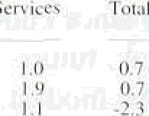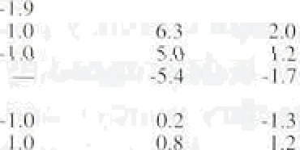

{see Table 5.B). lt is also unlikely that non-EC exporters have delayed raisi!ng their Sterling prices, thinking that. the depreciation of sterling was temporary (sterl.i.rig stands at a forward discount to tttese eurrericies).





t.' lx iiis}ioi i li i‘itv* (goods iiIilJ' i





nt:int t‹I‹t‹in:d n‹:mhm:tctitrc4

The slight firming of the exchange rate in the second quarter has rapidly fed thTOugh .to non-EC import prices. which fell .by 4.7% between Marctt arid June. .Although data on the. prices .of.i!mports.from the EC are not available beyond 1993 Q I, significant rises are unlikely ; indeed, the drop in import volumes from the EC since 1992 .Q3 coul‹i encourage EC exporters to reduce sterling prices to regain inarket str e.

1. 2 I t es

The i.mpact of import.prIces.on.domestic pr:ices shows.

'" " ' *'"’" "'” ””'* '’ ' ' " " " ”’ up fi:rst in the CSO’s series on input prices for

fit — ›.- i .*.: «.› c..‹ i.s ‹ ‹›.s *i.‹* manufacturing industries. Together, fuels ,and imported o\ 2.7 .›• 3.4 é.6 " .• .› › goods comprise around: two thi.rds of..th:is series. The

Qa ‹. .›.z ‹.7 .u i i.s /s. 4.t› ». 7.4 6.é' cost of fuels..and materials.purchased by manufacturing

.» !

firms rose by 8..7&• .between August 1992 an‹i Mai ch

1993. But it has since failen back, suggesting that .the initial impact:of higher import prices has now fed. through to input prices. In the second quarter, input prices were .7.4'fo higher than a year ago, with a smaller increase outside the food, ‹irink and tobacco .industnes (see Table. 5,C). Si.rice input.pnces:(excl!uding .those

**’l’uhlc** â.C’

Sliinu1’acturers’ input li rice inHation""

Percentage chanjos on ii yca'r curlier'

ivluteriiilx Petroleum AH Tol«l



industries) fell by 1.4% between June and August last year, following a rise i.n sterling’s exchange .rate, thei!r twelve-month:change.may P P

###### Floweâer,.as las! autumn’s.large monthly.increases drop

**prxiuccd** Impound %uels " and to›:1 out of the .anfiudl rate later in ,the year, i.np,ut..price .





-0:8



-0.7

The cost of.domestic inputs purchased.by manufacturers

###### ncreasefi’.rapidly between last August.and Febrt;ar/y.this

J0 18.



Q2

year,.tnueh in. like..with.’pncés.Sf i.riported materials, Despite firming in ltte,exchange rate since’ then, and the fall in the.price of imported inputs, prices of domestically produced inputs have continued to increase. To. the extent thdt inputs me widely traded in international markets, higher world: prices (denominated



in sterling) will be reflected in higher prices for products sourced locally. Prices of primary (rather than processled) food are particularly likely to reflect exchange rate *movements,* because *the* prices of localJy

*• •• produced food tend to move in line with changes in the ' green pound—the rate at which EC agricultural support

###### ""' — ‹° is converted into sterling.

3 Bu ne o b t

- 4

02

Chan 5.7

**Manufacturers’ price to cost ratios and the exchange rste**

*t98S—— IOi*



Espon saic

I976' 7g a0 Bz B4 x6' BB 9ti 92

**Table 5.D**

**.Contributions‹• .to manufacturers’ do iestic output**

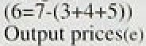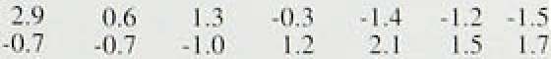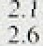

During a recession, pressure on businesses to lower margins contributes to a reduction in inflation. Provided firms cover their short-run variable costs they may continue producing even though prices are below

long-run costs. As the economy recovers, firms seek to restore profits. Chart 5.6 shows estimates of the rate of return on capital in industrial and commercial companies in the United Kingdom. Although profitability fell from its cyclical peak in the late 1980s, its level is higher than in previous recessions, and has started to rise again. The ratio of non North Sea profits to costs fell by 1.2' o in the first quarter of 1993, following a decline of almost 57c in the previous quarter. These declines reflect the fall in the exchange rate in September last year, which increased import closts. But a fall in the ratio of profits to costs need not imply a reduction in profits—if costs rise the ratio will fall even .if the rate of return on capital is unchanged.

In contrast to the domestic picture, manufacturers’ export margins were squeezed sharply in the recent recession, though not as much as in the 1980s. Between the end .of 1975 and the first quarter of 1981, UK manufacturers’ normalised unit labour cost competitiveness worsened by .over a quarter; the deterioration between end-1989 .and 1991 Ql was only one seventh. The explanation for the tighter squeeze on export than domestic margins may be that UK exporters are price-takers in world markets to a greater extent than in domestic markets. The extent of the earlier fall in

.export margins may be one reason why export prices increased so sharply following sterling’s fall last year: prices of exports to non-E£i countries increased by 9.7&o

.between August 1952 and March 1993.

The most recent data on profits are for manufacturing industry. **Table** 5.i3 illustrates the contribution of various factors.to:domestic.produc er **output price** inflation. It suggests that all but 0.3 **percentage** points of the 2.6& **increase in manufacturers'** domestic output prices in thq year to May came from higher margins.





IntJ4tit›n kcpon: August 1991 _

For manufacturers, faster rises in the price of materials and fuels have been virtually offset by falling unit labour costs.

The fall in sterling last September, combined with the earlier squeeze on export profitability, has prompted rapid increases in export margins, Domestic margins are unlikely to rise significantly .for two main reasons. First, profitability is higher at this stage of the .cycle than in the past. Second, firms are likely to rely mainly *an*

increases in output to restore profitability, rather than on increases in margins at a given level of output. A widening of margins is unlikely to pose a significant inflationary threat.

Henri tint i j 'ri



$

( •



-.

.

'. : .*

” '



Chart 6.I

tnftatioo expectations



The .outlook for inflation depends upon current inflationary pressures, and the interaction between monetary policy and the state of the real economy. The latter determines the speed at which inflation adjusts to the rate implied by the stance of monetary policy. That adjustment process is also dependent upon expectations of inflation. Evidence on private sector expectations of inflation can be obtained by looking at market yields on financial instruments and from independent forecasts and surveys. An essential element in the presentation of Bank projections for inflation to mid- 1995 is a comparison between the projections in the May *Report* and the central outtum for inflation over the past three months. Differences between the earlier and current

.longer-run projections reflect the ‘news’—both about inflation and the underlying state of the economy—that has emerged since the May *Report.*

# Evidence from financial markets

The last *Report* considered the evidence about inflationary expectations that can be derived from comparing yields on conventional and index-linked gilts. This evidence may be more reliable than that from surveys because the expectations of investors are reflected in their investment decisions, not just their statements. From the observed yield curves for nominal

'•• and index-linked gilts, it is possible to derive term structures for expected future short-term nominal and

* + • real rates of interest. The difference between these two term structures can be interpreted as the term structure of expected inflation, provided that the risk premium which

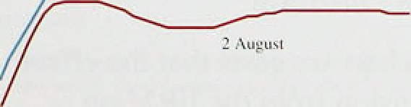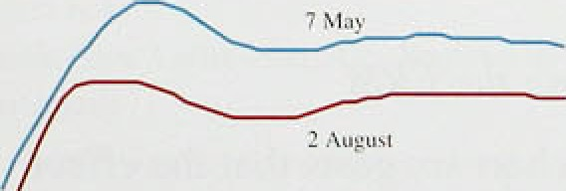

* + • is required on conventional gilts to compensate for the uncertainty about future inflation is small relative to the level of yields. (The method of construction is described
  + ’in more detail in the accompanying box). Chart 6.1 shows the term structure of.expected inflation calculated

' this way. It compares the .profiles of inflation expected

‹ on 7 May, as published in,the last /n/ ction *Report,* and 2 August. During those three months, expectations of future fnflatfon over the Hong and the medium-term fell by approximately half a percentage .pofnt. However,

Chart 6.1„ suggests that investors in the: gilts marhet either fi0 .a very,large **premiiim”to** coinpensate .for

uncertainty about future inflation or are still giving coixJiderable weight to the possibili.ty that future!

35



When sterling’s membership of the ERM was suspended last September, gilt prices reacted sharply. To a large extent, this i’eflected changes in investors’ expectations, particularly of future interest rates. These expectations are likely to have changed significantly, since UK interest rates would no longer be so closely tied to interest rates of other ERM member

Differences in yields between gilts of different maturities can be used to determine implied forward short-term interest rates and so to gauge the extent of changes in expectations.

Nominal implied forward rates, which can be tiroadly interpreted as the spot i’ates (ie

one-period current rates) which invesioivs expect will prevail over future yeiii's, can be derived from a par yield curve, calculated by fitting ‹i

i.i i v U tl i i W £pi 1.1 W U N • l Y D tJ I C1t1N U t I il liltq H

are linked to the RPI and are therefore to a large extent protected from inflationary losses. So the prices of index-linked **gilts** should reflect only expectations of real interest rates, and not experted inflation or the inflation risk premium, and real implied forward rates can therefore be derived from a real yield curve fitted to real yields on indexed gilts.

If it is assumed that the inflation risk premium is small relative to expected inflation, the

for ward nominal rate will be the sum of the expected inflation rate and the real interest rate on index-linked gilts. The implied inflation term structure is then constructed by subtracting the real implied forward rate curve from the nominal implied forward rate curve.

liii plied l’utii i e **iiil1;1l ion rnte• nri‹›i-v .hut** ii iivr i in'

s uspt'iisii iii ril' st vrliii g’s 1: R ñ I iiit'iii harsh ip i IN›/'l/'12 i

number of conventional gilts.

Using the Bank’s par yield cui’ve. the chart shows the nominal implied for wai’d rate cui’ves before and after the suspension of sterling’s ERM membership.

fn practice, implied for \Vai d rates will differ’ from expected future spot rates because investors will generally require compensation for bearing the risk that their expectations may not be fulfilled. The implied forward rate therefore equals the expected gilts spot rate plus a risk premium. Moreover, some may be priced at a premium or discount relative to others because they are attractive or’ unattractive to certain investors for tax or liquidity reasons.

On this basis, the chart suggests that the effect of Sterling’s suspension from the ERM on

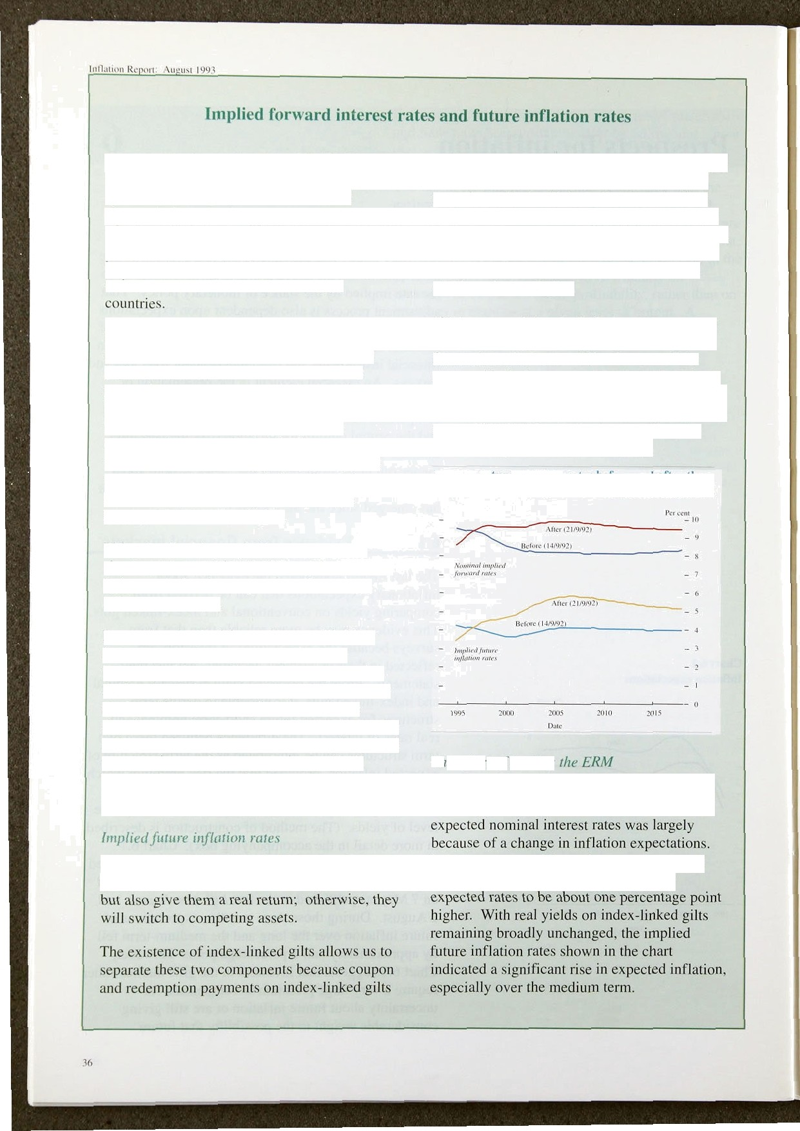

Gilt holders require yields which not only Investors expected lower interest rates in the compensate for anticipated inflationary losses, short term but over the longer term they

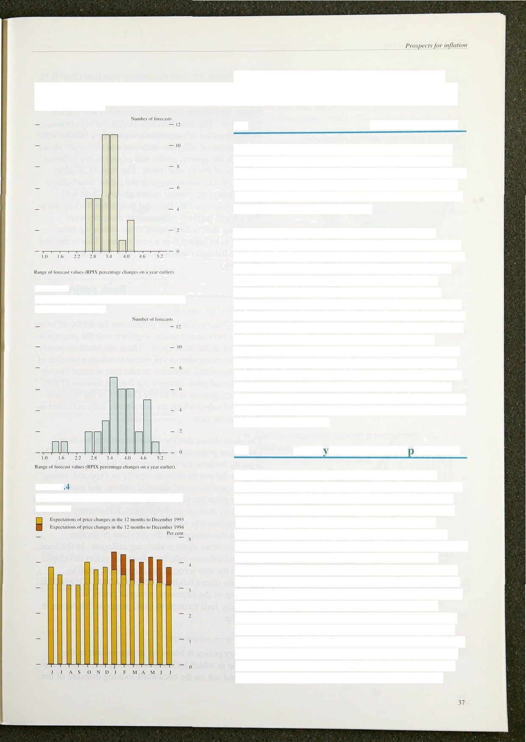

Chart 6J

**Distribution of** private **sector forecasts for**

**Chart 6.3**

**Distribution of private sector forecasts for inflation in 1994 Q4**

**Chart 6**

**Smitb New Court/Gallup Survey of fund managers**

governments will not adhere to the present inflation target. Long-term credibility in the inflation target has not yet been fully established.

* 1. **Outside forecasts**

Many institutions and companies publish forecasts of inflation. Chart 6.2 shows 36 private sector forecasts

for underlying inflation. The mean of these forecasts for underlying inflation in the year to the fourth quarter of 1993 is 3.5%. At the time of the *tnst* InftOtfGTl *Ref›ort,* it was 3.8%, and, in February, 4.1 %.

The outside forecasts embody a range of different assumptions about the future course of policy variables, such as interest rates, and about changes in the exchange rate. Although the effect of such assumptions will be limited as far as projections to the end of 1993 are concerned (there are lags between changes in these variables and inflation) their effect on projections to the end of 1994 will be substantial. The mean private sector forecast for underlying inflation in the year to the fourth quarter of 1994 is now 3.79c, which suggests that forecasters generally do not expect underlying inflation to pick up significantly in 1994 (see Chart 6.3). These forecasts have fallen since the last *Report* in May. when the mean was 3.9%, and February, when it was 4.3%.

Of the 36 forecasters, 25 now expect inflation to be at or below 4% by the end of next year, compared with 18 out of 36 three months ago.

## Surve s of inflation ex ectations

Recent surveys suggest, on balance, that inflation expectations have moderated since the last *Report.* The balance of respondents expecting to see a rise in their domestic output prices has shown a marked fall. from 10% in April to only 1% in July, according to the Quarterly **CBI** Industrial Trends Survey. Within the total, three quarters of respondents were not expecting to change their prices over the next four months, the

highest figure since the survey began in January 1972. Fund managers’ eKpectations of RPI inflation, for both end-1993 and end-1994, have not changed significantly since the last *Report,* according to the Smith New Court/Gallup Survey. As Chart 6.4 shows, for the past six months, fund managers have expected inflation to rise. In July they were forecasting a rate of 3.89c by the end of 1994. Using results from the Gallup Survey of employees’ price expectations, it is possible to derive **the balance of respondents** who expect inflation to



remain below .4% over the coming year (see Chart 6.5). By this measure, expectations .of inflation are still low compared with those ifi recent years, and employees still cxpect, on balance, that annual infiation will remain below 4%. The June Barclsys BASIX Survey shows most categories of respondents repoi ting a fall in their

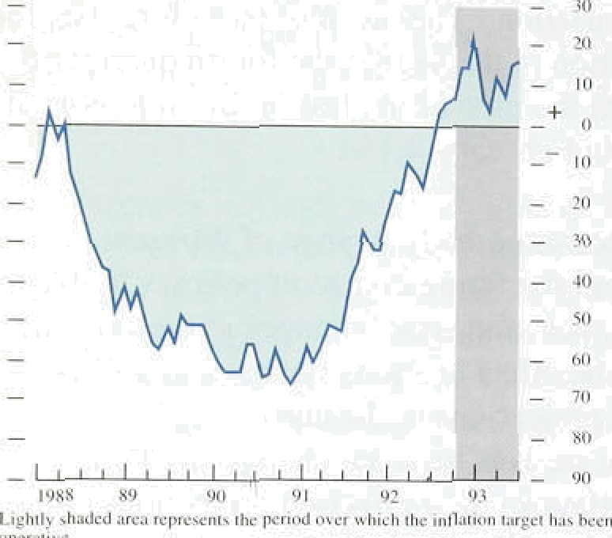expectations of i.nflation; both one anci two years ahead, although the general publ.ic still expect to see. inflation in cxcess of 4% by rriid- 1994. The Jtine. EC/Gallup Survey of consumers suggests the publ!ic now believe. that inflation has pnssed its trough (see Chart 6.6).

Results from the July Dun and Bradstreet Survey show that a small majority .of managing clirectors were expecting thtir selling prices in the following three months to be higher‘ than a year earlier. This is the first positive balance recorcied slnce Jmy 199 l (see

Chart 6.S).

#### 4 Bank o t o s

*Tlt‹' .s lioi’i- i’uu outl‹› ›k*

Chart 6.7 shows the latest projections for RPIX inflation. over the next three monlhs, together with the projections contained in the. last *Report.* These. are based on purely statistical extrapolations of recent.trends in a number of

.R.PI components. amended to take into account known administered price changes (eg Budget measures) and. known exogenous factors (eg changes in the seasonal pattern of sales) which are.not already fully ieflected .in the inflation rate.

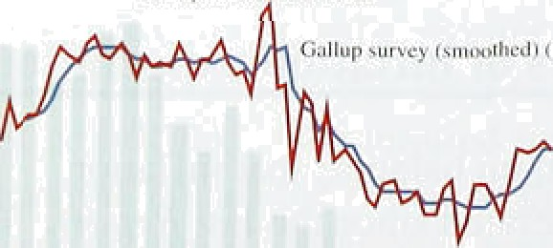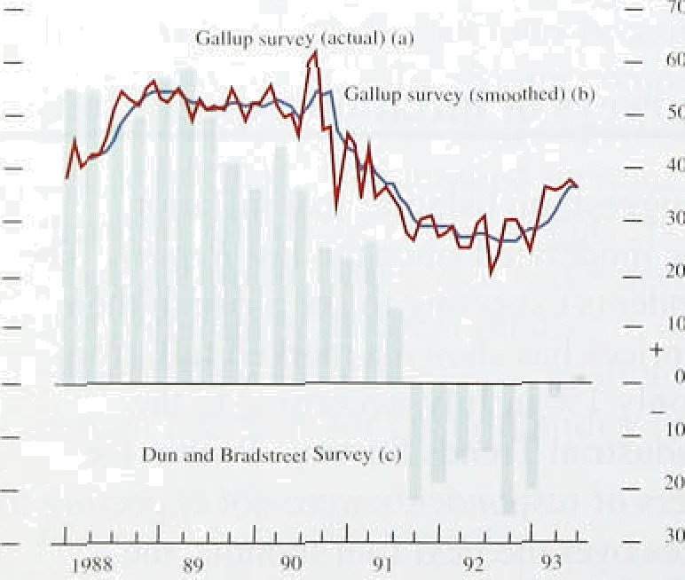

The chart shows that the inflation..outturn. has been lower than. projected at. the time of the l'ast *Report.* This is partly because the retail prices of food, dri.nk and tobacco did not.i.ncrease as rapidly as expected. taking Into account the usual seasonal pattern. and partly

because. price i.ncreases across the board w,ere .lower than implied by their recent ñ1eh'aviour. Inflationary.prdssures havé continued to weaken. Such.l;arge di.vergences between the outturn arid’.the pre/vious projectiori constitute .news. about underlying. in.flation. In .the food, drink and tobacco .industry. wholesale,prices:‹ieveloped at iriuch thé rate .foréc’ast but the yatio of retail .to. wholesale prices .tel.1 more!than..expeéted. }t is ’possiñ!e that more.of the increases..in import prices w.ill, eventual!ly'feefi through to mtail:priees. i.n thai sector in particula!r.





Monetary policy is based oman assessment of the. direction in which.inflation is moving one to two years ahead and n9t;on the backward-iooki!ng measure of.the



RPIX inflation projcctitiiis and outturns





_2.0





Cbart 6.8

RPM inflation projections and outturns



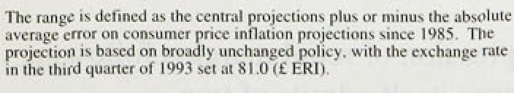



i.ncrease in prices over the past twelve months.

###### Chart 6.8 shows the Bank projections for RPIX inflation between now and the middle of 1995, together with the outturn to date and the projection published in the May

*.Repo,rt* (to December 1994). The projection is based on



of unchanged interest rates. Given that

United Kingdom and the rest of the world is close to zero, a broadly unchanged exchange rate, corresponding to ERI of 81, has been assumed.

The most likely outturn is that RPIX inflation will remain low for much Of 1993 but will pick up in the first half of 1994, moving towards, although r8malning below, the top of the target range. The main reason for the rise in RPIX inflation is the response of the index to changes in indirect taxes and in local authority taxes.

Excluding such effects, underlying inflation is expected to decline until the middle of 1994 and then remain roughly constant.

###### The current projections take account of the news since the last *Report.* The most important pieces of news have included:

R falls in unemployment: it is not yet clear what is happening to total employment, but it has reacted to output changes more rapidly in the l990s than in the past. The demand for labour appears to be increasing'

0 rises in output and industrial production: the evidence is consistent with a slightly faster recovery than expected; and

###### R lower retail price levels: the depreciation since last autumn has had much the effect expected on import and input prices, but retail prices have

.been lower than forecast.

The impact of this news has led to a downward revision

.in the central projection for inflation (see Chart 6.8). The best indicator of underlying inflation at present—

.the increases in RPIX excluding local authority and indirect taxe increased somewhat at the end of last year reflecting the rise in fmport prices. But it has started falling again and is likely to remain low for some

.time., The evolution of the monetary aggregates, discussed in Section 2, is consistent with this outlook for inffaoon. There is gtill a Substantial output gap and high



#### .conhnue to qâert.down:wards}nessure on.inflation.



lnttntit›n Reycrt: August 100j

The measures announced in the last Budget (together with the change of local tax regime) are expected to raise **RPIX** inflation by 0.2 percentage points in the first quarter of 1994 (the effect of the two rounds t›f excise duty indexation likely within the year) .and by

0.4 percentage points in the second quarter of 1994 and by 0.5 percentage points in 1995 (extension of the VAT base). The effects of the switch from the Community Charge to the Council Tax will also disappear from the twelve-month change in the index In the second quarter of 1994. These measures account for the .rather different outlook for RPIX inflation than for a more accurate measure of underlying inflation.



There are three mnin sources of uncertainty surrounding the central proJection. The first, and ever present, uncertainty surrounds the future behaviour of the exchange rate. The recent turmoil in the ERM has created greater uncertainty about interest rates on the Continent, and hence about the exchange rate between sterllng and the ERM currencies. An earlier than expected reduction in interest rates in those countries would, in part, lead to .faster recovery there and hence. better prospects for UK exports, and, in part, a higher sterling exchange rate. On balance, the outcome would be a slightly lower.inflation rate titan implied by the central projection.

The other two sources of uncertainty repmsent risks that inflation might be higher than expected. The first surrounds the real rate of return on capital that is required to generate levels of investment consistent with economic recovery. Supply-side reforms have raised the rate of return on capital in the United Kingdom. The central projection is based on the view that profitability is high relative to comparable points in the cyc1el in the past, land that further increases! in.profits will result from a return of output to trend. B.ut, if the.long-run requi.red rate of.return is higher than:can be generated in this way, successful firms might start to'increase prices %r a given level.of costs, resulti.ng.in.a nse:in margins..

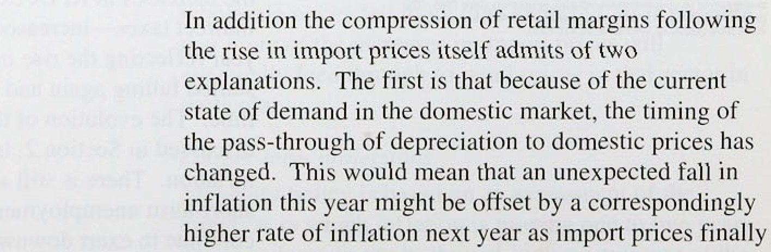



pass through to higher prices in the shops. The second explanation is that competition in the retail sector has lowered the long-run level of profit margins and that the increase in impori prices will be absorbed in margins not only in the short run but also in the long run. It is simply too eariy to tell which *e*ff*ect* is the more important.

The other uncertainty is about earnings. Nominal earnings depend on the real level of earnings expected by wage bargainers and consequently on their price expectations. There is a tisk that a slower growth in real wages may lead bargainers to aim for higher

pre-tax earnings. More important. their price expectations will determine which will prevail, low rates of increase in money earnings and low inflation or higher rates of increase offset by more rapid increases in prices. A belief that the inflation target will be met will help *make* the former more likely.

41



Inflation has continued to fall throughout the period since the May Report. The headline inflation.rate has fallen to 1.29 a year, the lowest for nearly thirty years. Underlying inflation, defined in terms of RPIX, has fallen from a rate of 3.5&o in March to .2.8&• in June, the lowest figure since the index first became available. In terms of arithmetic, the fall in inflation is accounted for by the switch from the Community Charge to the.

###### Council Tax which reduced average household

payments. This one-off change will affect the twelve- month rate of inflation tintil next spring when the effect drops out of the index. But the reduction in inflation over the past three months was more rapid than anticipated, and its explanation is not to be found in the change in local authority taxes. One of the reasons

for such a marked slowdown was that the impact of sterling depreciation on import prices has been offset by a reduction in unit labour costs, leaving total costs broadly unchanged. Profits in.manufacturing .rose slightly and inflation fell. In addition, retail margins in sectors such as food, drink and tobacco may have been reduced.

The Bank’s central projection is that inflation will remain within the target range over the next two years. It is important to distinguish between RPIX inflation, used in the deftnition of the target range, and a measure of underlying inflation which excludes changes in both indirect and local authority taxes. Excluding the effects of taxes, the underlying rate of inflation:is expected to decline further over the next year and then to remain broadly constant into 1995. In:cDntrast, RPIX inflation will increase in the first half.of 1994 as a result of the extension of VAT to domestic fuel and power (and any indexation of excise duties to be announced in the November Budget) and the change!from the Community Charge.to!the.Council Tax dropping out of:the

twelve-month rate. The.official..:measuie:if underlying in!flation.may,: therefore, be close‘tti’tiie top.of the target

!rangein the .first half of 1994.

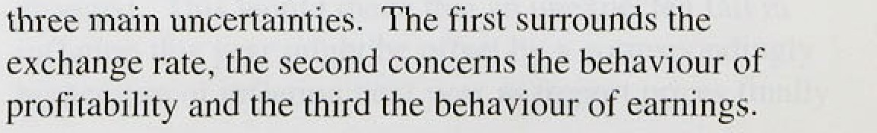



A higher than expected sterling ERI Would, other things being equal, put fiirtlier downward pressure on inflation in the short run. But the impact of any changes in the exchange rate would depend on the reason for that change. A rise in sterling which resulted from news that recovery was more rapid than anticipated would have a smaller effect on inflation than a rise which resulted from lower interest rates abroad.

###### Although business profitability is much higher than at comparable stages of the cycle in the past, those levels of profiu were unsustainably low. Profits will rise

further as output returns to trend. But, if this fails tO produce an adequate real rate of return on capital, there may be upward pressure on prices as well as downward

pressure on costs.

The third source of uncertainty concerns the rate of increase of nominal earnings. The high level of short- term unemployment and the rapid growth of real wages relative tp productivity in recent years should lead to a marked slowing down in the growth of real wages over the next two years. Provided that firms and employees are confident that inflation will remain well within the target range, this adjustment in the growth of real wages will occur at lower rather than higher rates of inflation.

The evidence on expectations of inflation suggests that it is expected to remain within the target range over the next two years or so. But market expectations derived from the yield curve do not yet appear to be consistent with the achievement of the inflation target over the next decade. Credibility of the target over this horison matters because it affecu the level of long-term interest rates. Such rates are also influenced by the level of the budget deficit. The prospective rise in the ratio of government debt to CiDP is of concern because it may lead to fears that the real burden of this debt will eventually be monetised.

Tbe growth of the monetary aggregates, and monetary policy more generally, are consistent with inflation remaining within the target range over the next two years, Expectations of inflation on the part of firms and employees are important because they detemiine whetber,1given the i onetary stance, the level of nominal wagm Chieh results from bargaining generates the

ecteii level of mal wagea and employment. Tke heat rt›duOtto in inflgtion improve the prospect that ioflatipowillremain within the target range, which will

##### tbecealibiiity at @e target range itself. Bui it



g

to the target range



interpreted simply as holding inflation below 4% a year. Part of the original statement of the target was that inflation should be in the !ower half of the range by the end of this Parliament. That outcome is within reach provided that monetary policy does not accommodate increases in nominal costs, and that fiscal policy does not threaten the inflation target in the longer run.



Reprinted from the *August* Bank of England Quarterly Bulletin

###### Pi ice é4.0(l